ClearCost User Manual

A guide to using ClearCost software to collect datasets for the Whole of Government Benchmarking Exercise

Version 0.1

Prepared for the

**Department of Finance**

June 2017



Contents

1 Introduction 3

1.1 Background 3

1.2 ClearCost 3

1.3 Purpose of Manual 3

1.4 Responsibilities 4

2 Screen Elements 5

2.1 Opening your Database 5

2.2 Navigation 6

2.3 Understanding Categories 7

2.4 Understanding Tree-view 8

2.5 Understanding Toolbars 8

2.6 Calculation Triggers 10

3 Setting up Cost Centres 11

3.1 Adding Cost Centres 11

3.2 Editing Cost Centres 13

3.3 Deleting Cost Centres 13

3.4 Clearing (deleting) Expenses from a Cost Centre 14

4 Setting up Account Codes 15

4.1 Adding Account Codes 15

4.2 Editing Account Codes 16

4.3 Deleting Account Codes 17

5 Recording Expenses 18

5.1 Adding Operating Expense Items 18

5.2 Editing Items 21

5.3 Deleting Expense Items 22

6 Allocating Expenses to Activities 23

6.1 Adding Expense to Activity Allocations 23

6.2 Changing Expense to Activity Allocations 26

6.3 Copy Activity Allocation Sets 27

6.4 Remove Expense to Activity Allocations 27

7 Allocating Activities to Services 28

7.1 Finding Activities 29

7.2 Adding Activities Allocations to Services 30

7.3 Changing Activity Allocations 32

7.4 Copy Service Allocation Sets 33

7.5 Spread – Overhead Activities to Services 34

7.6 Remove Activity to Service Allocations 36

8 Volumetrics (Units) 37

8.1 Apply Calculated Rates to Specified Rates 38

9 Basic Reporting 40

9.1 Generating Reports 40

9.2 Generating Charts (Dashboards) 42

# Introduction

## Background

The Department of Finance’s (Finance) Shared Services Program (the Program) requires all non-corporate Commonwealth agencies to participate in an annual Whole of Government Benchmarking Exercise (**the Exercise**) to compare corporate service costs across all non-corporate Commonwealth agencies. Corporate services include Financial Services, Human Resources, and Corporate Services, but excludes ICT Services at this stage.

## ClearCost

To facilitate the Exercise, Finance has purchased ClearCost for all agencies to utilise for the collection of datasets. ClearCost is a software package designed to integrate the key financial processes that underpin services within an agency. It works with an agency’s existing Financial Management and Information System (FMIS) to assign costs and resources to activities and services.

The purpose of the system is to lift cost transparency and to provide accountable outputs. It focuses on aligning costs to services, through activities and drivers, rather than the traditional method of focusing on costs at responsibility or organisational centres. This increases the resultant cost data utility and reinforces a service-based approach through recording and tracking of expenditure along similar lines across the Commonwealth.

## Purpose of Manual

The purpose of this Manual is to provide **basic** information on how to use ClearCost for the purposes of the collection of datasets for the **Exercise**. It is **not** an extensive manual covering all aspects of ClearCost, rather it has been tailored to assist Users in successfully answering queries that may arise as part of the Exercise.

The structure of the Manual is divided into the following Sections:

* Screen Elements
* Setting up Cost Centres
* Setting up Account Codes
* Recording Expenses
* Allocating Expenses to Activities
* Allocating Activity Cost-Pools to Services
* Volumetrics
* Basic Reporting

# Responsibilities

To enable small agencies to participate and capture the required information necessary for the uploading of data on the Whole of Government benchmarking portal, Synergy will provide these agencies with an Excel template. Agencies will be required to obtain CFO sign-off on the information provided in this template only.

For all other agencies required to input data into ClearCost, this manual (and training) will provide sufficient support for you to complete the Exercise. Synergy will be available for additional support throughout the Exercise, however it is the agency’s responsibility to provide the completed ClearCost data and obtain CFO sign-off.

# 

# Screen Elements

## Opening your Database

When you run ClearCost, the application will request that you nominate the database you wish to work on. The following screen will be shown.

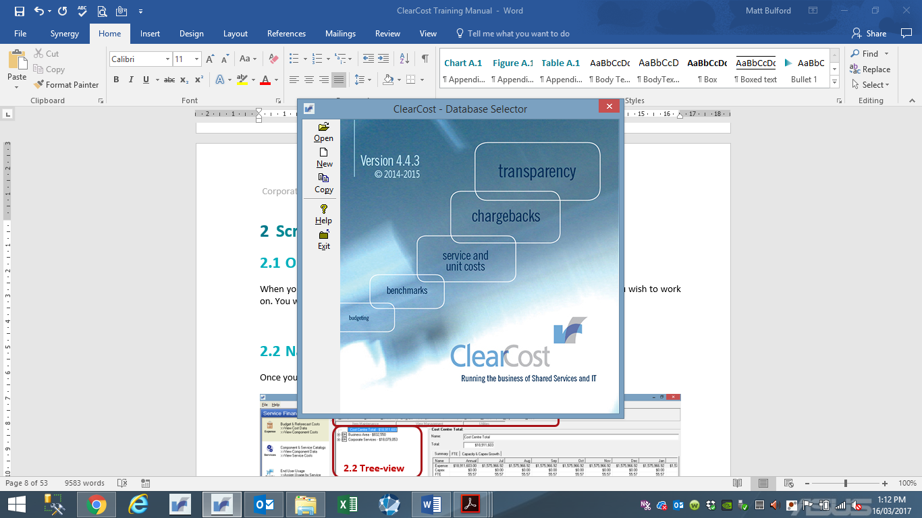

There are three options available:

* Open an existing database – allows the User to open an existing database. The files are identifiable by the file extension ‘.itb’. The process of selecting and opening file uses the standard Microsoft Windows file opening steps.

Once the file is found you will be prompted for a User Name (default is **Admin**) and a Password (default is **CC**).

* Create a new database – allows the User to create a refresh database. Only an Administrator should use this function as the new file will be empty and will require at least one Cost Centre and one Account Code to be set up before expenses can be recorded. **DO NOT USE** this function.
* Copy an existing database – this option allows the User to make a copy of an existing database. The new file will be identical to the original file with two exception, the file name and Audit Log will be cleared in the new copy.

You will be requested to nominate a file to copy, then be prompted to supply a new name for the copy. After the copy is made, the Users will be returned to the initial menu where one can make further copies, or open the file just created.

## Navigation

Once you have selected a database and logged in, the Management Dashboard of the Main Menu will display (refer to Section 9.2 for Management Dashboards).

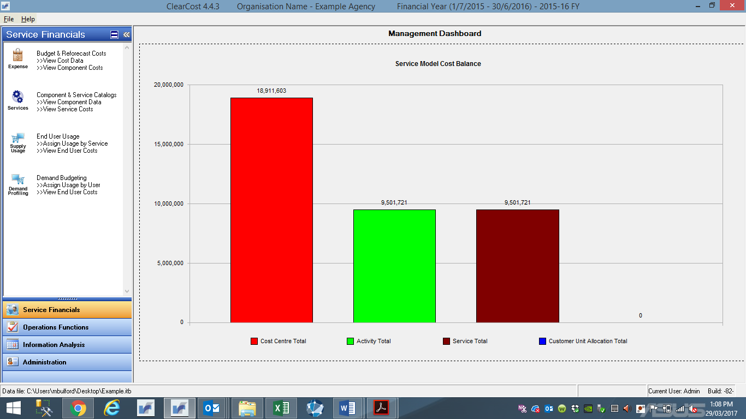

Click on one of the Service Financials (to the left) to display the Main Menu screen as below. This Main Menu will be referred to throughout this Manual.

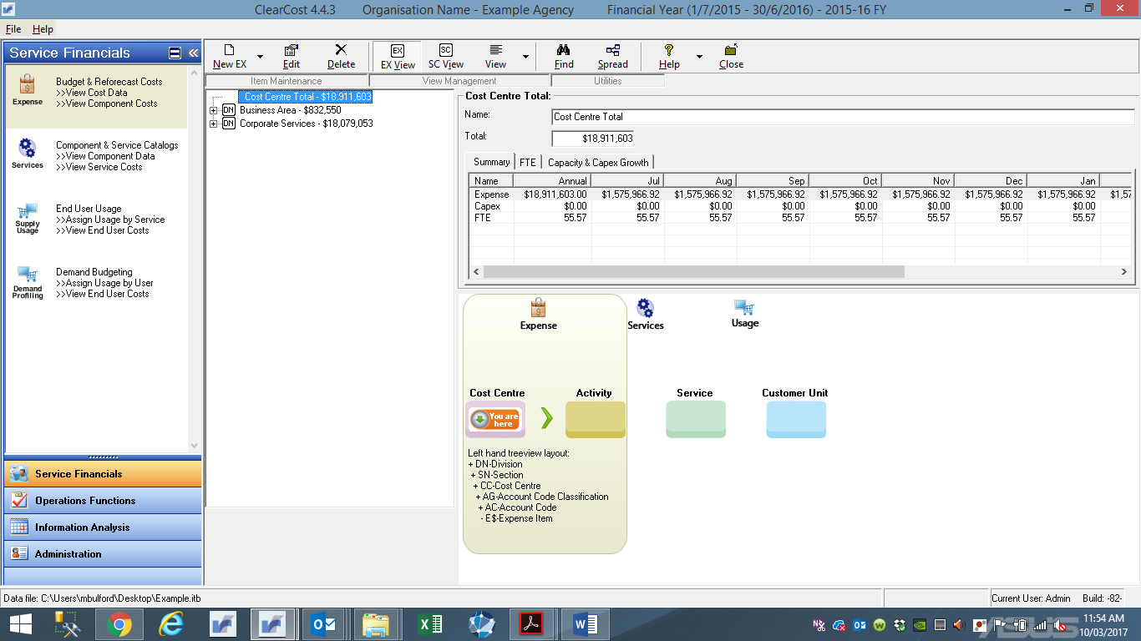

**2.4 Tree-view**

**2.5 Toolbars**

**2.3 Categories**

## Understanding Categories

Functions are clustered into several categories on the Main Menu:

* **Service Financials** – mainstream user functions for cost, activity, and service modelling
  + Budget & Reforecast Costs – enter and maintain expense items and allocation to activities
  + Component & Service Catalogs – enter and maintain activities and assign to services
  + End User Usage – allocate usage to each service based on volumes
  + Demand Budgeting – allocate usage by customer unit (**not applicable for the Exercise**)
* **Operations Functions** – for Administrator only (**not applicable for the Exercise**)
* **Information Analysis** – functions to produce reports, charts or view past data for comparisons
  + Report Menu – view and print reports
  + Chart Menu – view and print charts
  + Data Warehouse – generate and extract data warehouse information (**not applicable for the Exercise**)
  + Trending and Past Period Data – view history
* **Administration** – functions to establish and maintain database framework
  + Maintain User Authorities – setup and maintain user access and records (**not applicable for the Exercise**)
  + Bulk Data Imports – upload existing spreadsheet based data, being either Reference Tables, expenses, or allocations
  + Bulk Data Exports – export or download data

## Understanding Tree-view

The tree-view helps the User to view costs and other data on-screen. This example shows the Cost Centre expenditure tree-view in the Expense/Budget view under the Budget & Reforecast Costs Category.

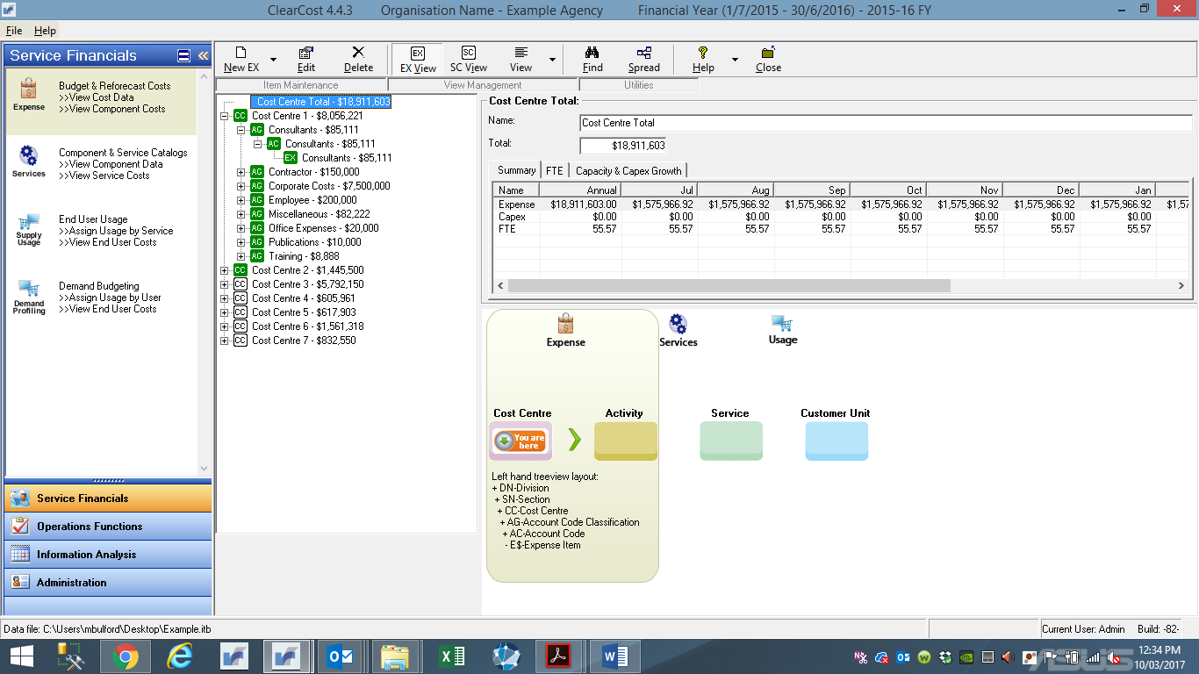

The tree-view is made up of Folders and Nodes. Folders are used to organise the tree-view content. In the example above the folder represents Cost Centres that account codes and expenses items are housed in. Nodes are an element of information, such as account codes, expense items, an activity, or a service.

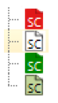Tree-views are colour coded to represent the state of an allocation of a Node. Allocation examples include, Expenses to Activities (Section 6.2), and Activities to Services (Section 7.2). The colour represents:

Red = under/overallocation of a node

White = 0% allocated

Green = 100% allocated

Light green = 99.5% to 100.5% allocated.

## Understanding Toolbars

Toolbars are provided for each Service Financials screen to allow Users a quick and simple method for executing common functions. Each button on the toolbar performs a specific function. To see the purpose of each button, hover the mouse pointer over the button (without clicking).

The following table contains the ‘most common’ function buttons.

| **Button** | **Function** | **When button appears** |
| --- | --- | --- |
|  | NEW EX – Add new Expense Item – ignore the drop-down box as only Expense Items are used for this Exercise. | Expenses/Budget View of Budget & Reforecast Costs Category |
|  | NEW AY – Add new Activity (**DO NOT USE** – activities are pre-determined from Service Catalogue) | Activity View of Budget & Reforecast Costs Category; and Component & Service Catalogs Category |
|  | NEW BS – Add new Service (**DO NOT USE** – services are pre-determined from Service Catalogue) | Service View of Component & Service Catalogs Category; and End User Usage Category |
|  | Edit the selected item or element | All Categories |
|  | Delete the selected item or element | All Categories |
|  | Expenses/Budget View – list Expenses by Division and Section (default) | Budget & Reforecast Costs Category |
|  | Activity View – list Activities by Activity Function (default) | Budget & Reforecast Costs Category and Component & Service Catalog Category |
|  | Service View – list Services by Service Group and Service Type | Component & Service Catalog Category and End User Usage Category |
|  | Enables viewing of the data in different ways. This is a very important button as it allows the User to view each Category within a range of different views. For Example, for Budget & Reforecast Costs Category, Expenses/Budget View, the User can select the data to be shown as Division, Section, Cost Centre, Account Code, Cost Category…etc. | All Categories |
|  | Search for an Expense Item with a word or part of a word for name, description, or reference (can use * as a wildcard) | All Categories |
|  | Spread overhead costs across selected Services | Activity View of Component & Service Catalog Category |
|  | Inherit allocations from Assets associated with Activities (**DO NOT USE**) | Activity View of Component & Service Catalog Category |
|  | Used to allocate Customer Units to a common usage set (**DO NOT USE**) | End User Usage Catalogue |
|  | Merge (combine) services into bundles (**DO NOT USE**) | End User Usage Catalogue |
|  | Takes the system’s Calculated Rate for a Service and copies it to the Specified Rates field | End User Usage Catalogue |
|  | Variation of the Commit function in the determination of Specified Rates field (**DO NOT USE**) | End User Usage Catalogue |

## Calculation Triggers

On a general level, ClearCost calculations occur in **real time**. At a ‘data-entry’ level, inputting certain data is checked for validity as it is entered or when the User clicks **OK** or **SAVE**.

As a rule, any change in data values or allocations will produce a change downstream. However, it is important to note that Services have a Specified Rate that are not geared to automatic cost changes. Accordingly, when changes are made to cost allocations to Services, Users will be required to adjust the Specified Rate and/or Commit Rate (refer to Section 8.2 for further information).

# Setting up Cost Centres

For the Exercise, the process of establishing cost centres and associated expenses in ClearCost will be undertaken by agencies through the completion of the cost base template provided to each agency by Synergy.

**Please note that completed cost base template will be uploaded into ClearCost by Synergy**. Accordingly, the following Sections are incorporated into this Manual to provide transparency in the processes that may allow a user to change allocations should there be a requirement after the collection and input of the completed cost base template into ClearCost.

## Adding Cost Centres

Use this procedure to set up details of a Cost Centre.

**Before you start**

You will need to know which Cost Centres to set up, as well as the ‘Section’ and (if applicable) classification of each Cost Centre.

**Procedure**

1.Click **File > Configure Data Model > Reference Tables**. The Reference Tables window will display.

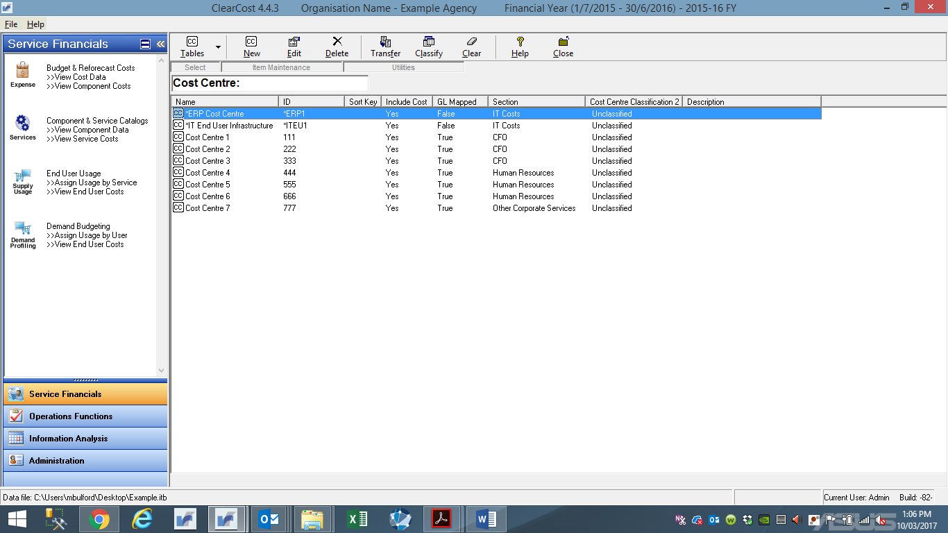

2. The default view is the Cost Centre table. If this does not appear, click the drop-down box on **Tables** button and select **Cost Centre**. The Cost Centre window will display as above.

3. To add a new Cost Centre click **New**.

The Add Cost Centres window will display.

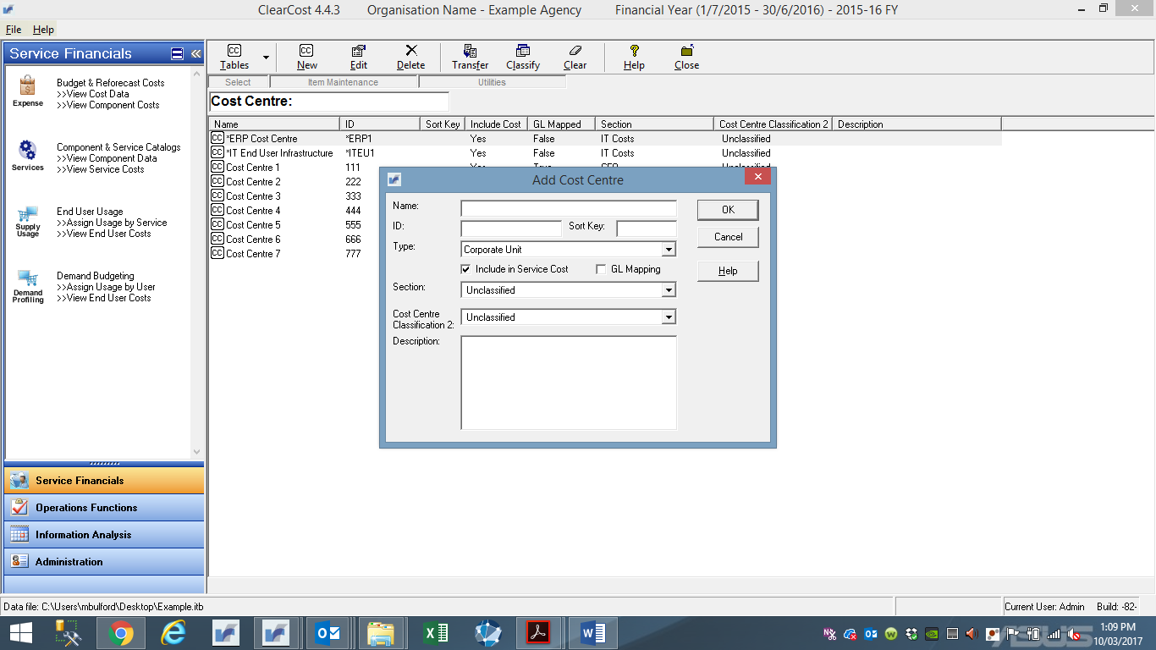

4.Only the Name and ID fields are mandatory, but other fields will be needed to make the model reflect a correct structure. Enter values in the fields as follows:

* In the **Name** field, enter a description of the Cost Centre. The name can be up to 50 characters, and can be any combination of letters, numbers and spaces. It is best practice to use the naming conventions in your agency in accordance with FMIS whenever possible. Where the name exceeds the character limit, try to keep the name as brief as possible, but ensure that it is meaningful to all users of the system.
* In the **ID** field, enter the unique code that represents the Cost Centre in the FMIS. The ID can be up to 20 characters in length, and can be any combination of letters, numbers and spaces.
* In the **Type** field (information only), select one of the pre-set values from the drop-down list:
* **Corporate Unit** (default)
* **Support Department** (**DO NOT USE**)
* **Business Unit** (**DO NOT USE**)
* The **Sort Key** field is a user defined field. Contrary to its name, it has no effect on sorting in tree-views and reporting. Treat it as a custom field (e.g. an alternative reference number for the Cost Centre).
* In the **Section** and **Classification** fields, select from the drop-down list.
* **Include in Service Cost** field will be selected () as a default. If you do not want this Cost Centre to be included in Service Rate calculations, de-select the field (click on the tick – it should disappear) – this will only be applicable for very specific circumstances.
* **GL Mapping** indicates this Cost Centre will be included in GL Load status checking (refer GL Actuals Load Utility).

If you cannot complete all the fields now, just save what you have entered (Hit OK).

5.When you have completed all fields, click **OK**. The Reference Tables view will be displayed, set to the Cost Centres list with the additional Cost Centre.

6.To return to the main menu, click any of the Main Menu categories displayed on the toolbar.

## Editing Cost Centres

Use this procedure to edit details of an existing Cost Centre.

**Procedure**

1. Click **File > Configure Data Model > Reference Tables**. The Reference Tables window will display.

2. The default view is the Cost Centre table. If this does not appear, click the drop-down box on **Tables** button and select **Cost Centre**. The Cost Centre window will display.

3. To edit a Cost Centre select the Cost Centre by clicking on the entry in the list to highlight it, click the **Edit** button, or just double-click on the Cost Centre icon you want to edit.

The Edit Cost Centres window will display.

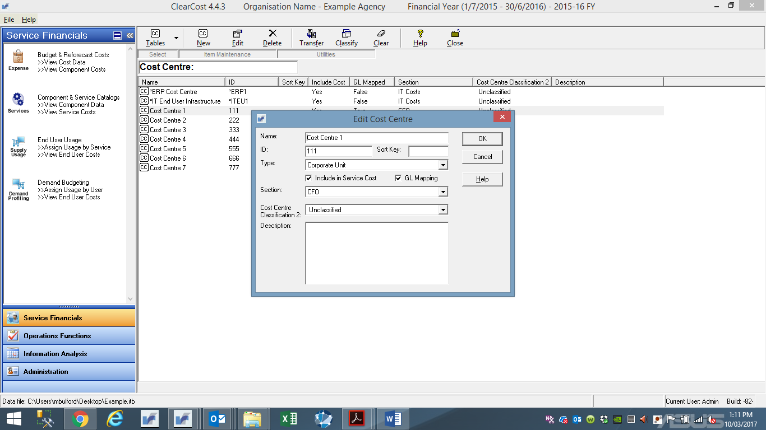

4. Enter the new value by either overtyping the field or selecting the value from a drop-down list.

5. When you have completed all fields, click **OK**. The Reference Tables view will be displayed, set to the Cost Centre list with the change to the Cost Centre.

6. To return to the main menu, click any of the Main Menu categories displayed on the toolbar.

## Deleting Cost Centres

Use this procedure to delete an existing Cost Centre.

**Before you start**

Before you delete a Cost Centre, you must either: (1) delete all expense items relating to that Cost Centre (refer to Section 3.4); or (2) move the expense items to another Cost Centre (refer to Section 3.5).

**Procedure**

1. Click **File > Configure Data Model > Reference Tables**. The Reference Tables window will display.

2. The default view is the Cost Centre table. If this does not appear, click the drop-down box on **Tables** button and select **Cost Centre**

3. To delete a Cost Centre, select the Cost Centre by clicking on the entry in the list to highlight it, click the **Delete** button. A message asking you to confirm this action will display, click **Yes** to delete (or **No** if you wish to abort the Delete process).

4. The Reference Tables view will be displayed, set to the Cost Centres list minus the deleted Cost Centre.

5. To return to the main menu, click any of the Main Menu categories displayed on the toolbar.

## Clearing (deleting) Expenses from a Cost Centre

Use these procedures for deleting expenses in a Cost Centre, together with the expenses’ associated Activity allocations from the database.

**Procedure**

1.Click **File > Configure Data Model > Reference Tables**. The Reference Tables window will display.

2.The default view is the Cost Centre table. If this does not appear, click the drop-down box on **Tables** button and select **Cost Centre**. The Cost Centre window will display.

3. Click the Clear button.

The Delete Expenses from Cost Centre window will display.

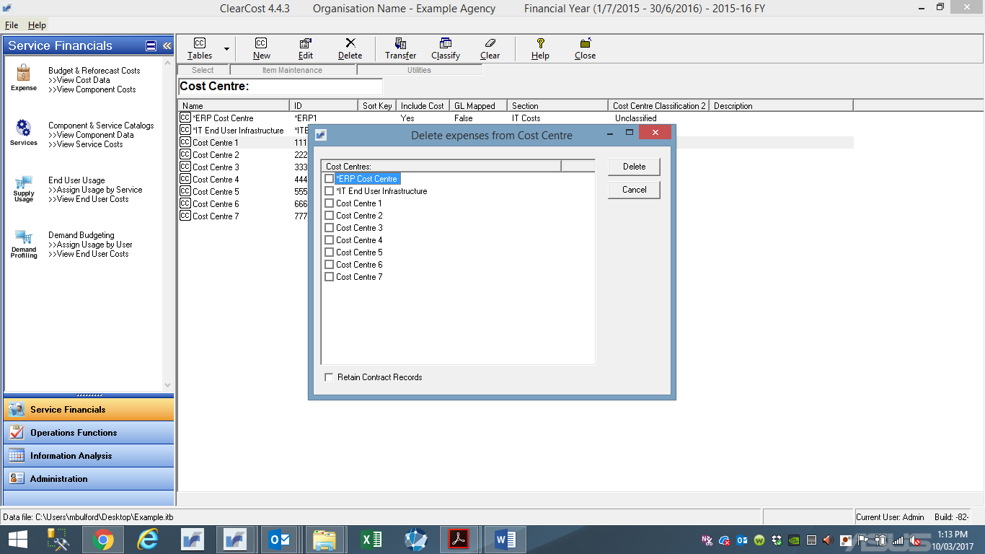

4.Click the Cost Centre(s) you want to delete expenses from.

6.Click **OK**. A message is displayed warning that all expenses in the chosen Cost Centre(s) and their associated allocations (to Activities) will be deleted from the database.

7.Click **Yes** to proceed, or **No** to cancel the process. Please note that this function does not delete the Cost Centre from the table.

8. The Reference Tables view will be displayed, set to the Cost Centres list.

9. To return to the main menu, click any of the Main Menu categories displayed on the toolbar.

# Setting up Account Codes

## Adding Account Codes

Use this procedure to set up an Account Code.

**Before you start**

You will need to know which Account Codes to set up. These must be consistent with the Account Codes in the agency’s FMIS.

**Procedure**

1.Click **File > Configure Data Model > Reference Tables**. The Reference Tables window will display.

2.The default view is the Cost Centre table. Click the drop-down box on the **Tables** button and select **Account Code**.

The Account Codes window will display.

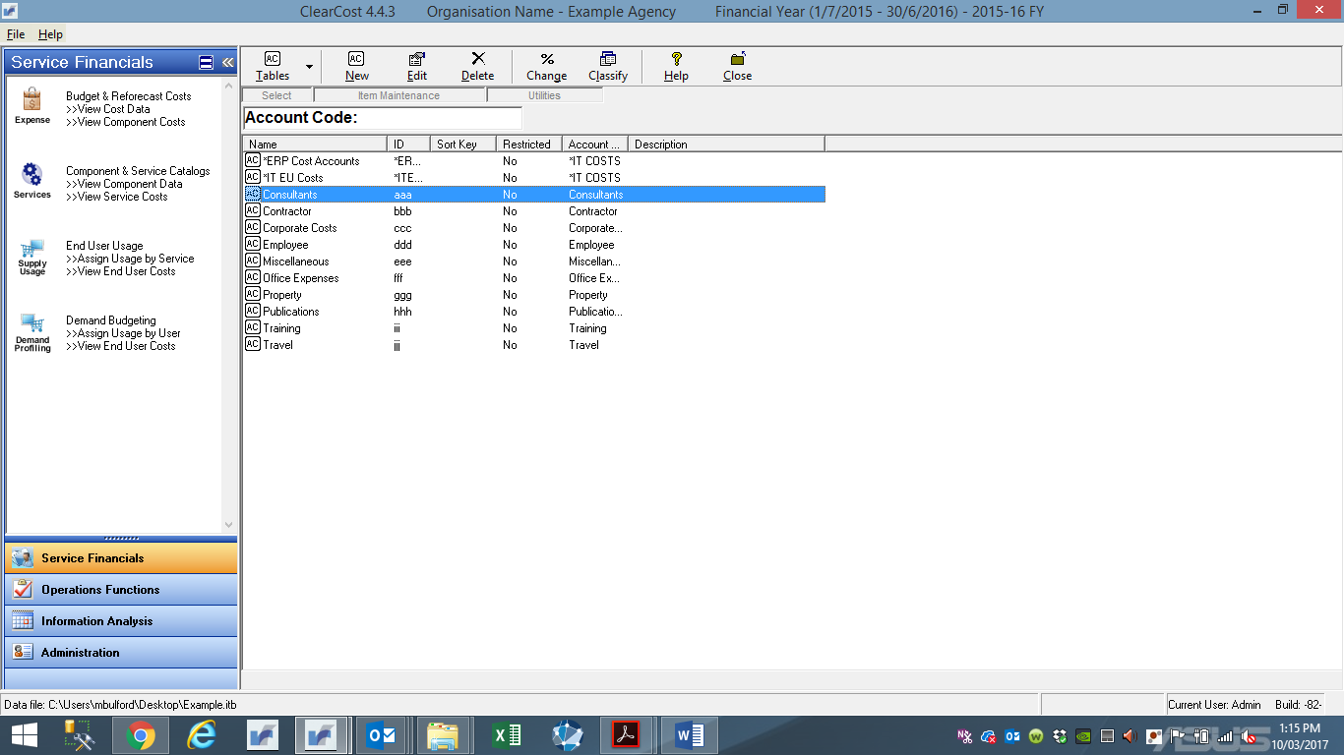

3. To add a new Account Code click **New**.

The Add Account Code window will display.

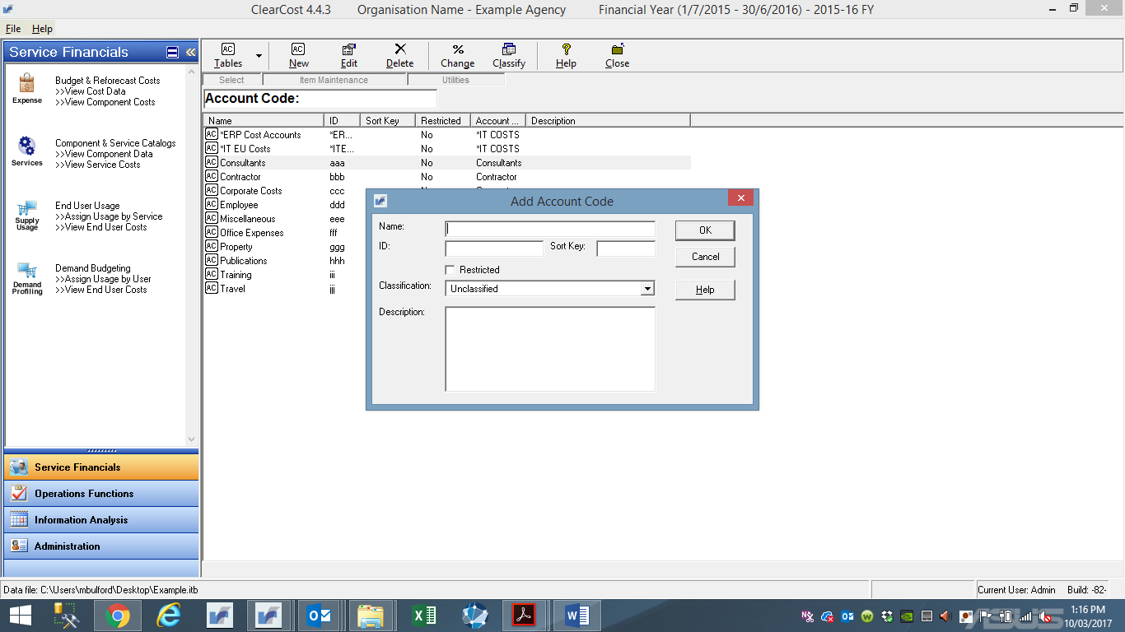

4. Only the Name and ID fields are mandatory, but other fields will be needed to make the model reflect the correct structure. Enter values in the fields as follows:

* In the **Name** field, enter a description of the Account Code. The Name can be up to 50 characters, and can be any combination of letters, numbers and spaces. It is best practice to use the naming conventions in your agency in accordance with FMIS whenever possible. Where the name exceeds the character limit, try to keep the name as brief as possible, but ensure that it is meaningful to all users of the system.
* In the **ID** field, enter the unique code that represents the Account Code in the FMIS. The ID can be up to 20 characters in length, and can be any combination of letters, numbers and spaces.
* The **Sort Key** field is a user defined field. Contrary to its name, it has no effect on sorting in tree-views and reporting. Treat it is a custom field (e.g. an alternative reference number for the Account Code).
* The **Restricted** field is used to restrict access to expense items under this Account Code. The combination of this field ticked (✓) and the selection of restricted access to nominated Cost Centres through Maintain User Authorities (not covered within this Manual) will ensure that such Users will not be able to view Expenses of this Account Code in the nominated Cost Centres.
* The **Classification** field allows you to identify an account code as being part of a common expense item (e.g. consultants, contractor, corporate costs, employee, miscellaneous, other expenses, property, training, travel etc.)

4. When you have completed all fields, click **OK**. The Reference Tables view will be displayed, set to the Account Codes list with the additional Account Code.

5. To return to the main menu, click any of the Main Menu categories displayed on the toolbar.

## Editing Account Codes

Use this procedure to edit details of an existing Account Code.

**Procedure**

1.Click **File > Configure Data Model > Reference Tables**. The Reference Tables window will display.

2.The default view is the Cost Centre table. Click the drop-down box on the **Tables** button and select **Account Code**. The Account Codes window will display.

3. To edit an Account Code select the Account Code by clicking on the entry in the list to highlight it, click the **Edit** button, or just double-click on the Account Code icon you want to edit.

The Edit Account Code window will display.

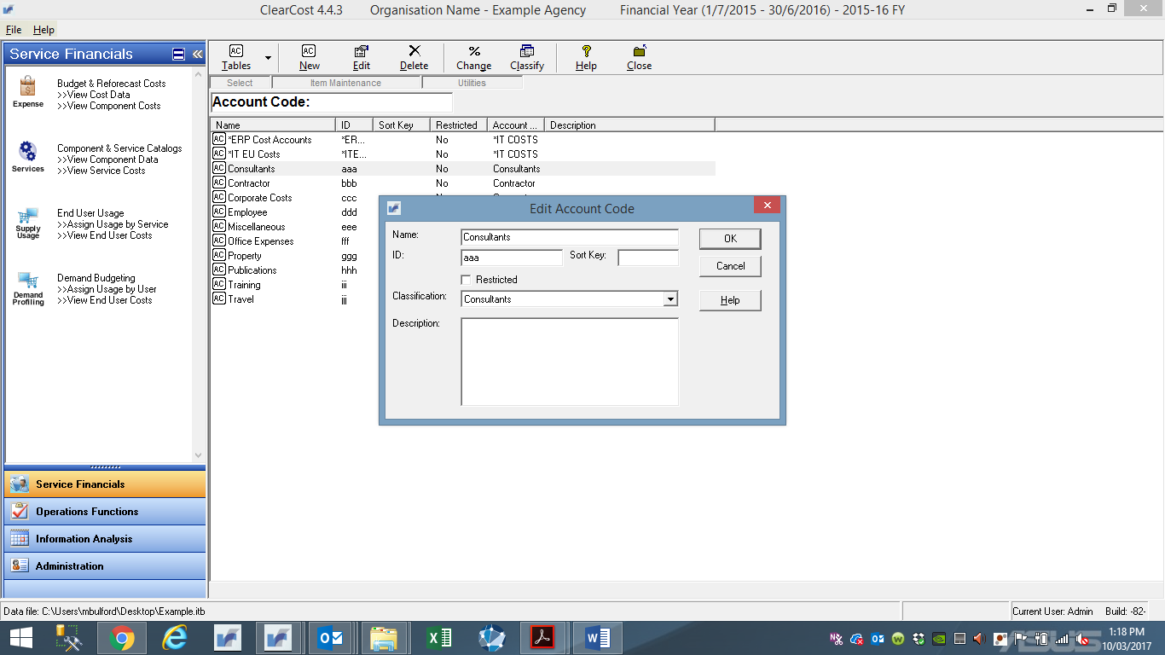

4. Enter the new value by overtyping the field or selecting the value from a drop-down list.

5. When you have completed all fields, click **OK**. The Reference Tables view will be displayed, set to the Account Codes list with the amended Account Code.

6. To return to the main menu, click any of the Main Menu categories displayed on the toolbar.

## Deleting Account Codes

Use this procedure to delete an existing Account Code.

**Before you start**

Before you delete the Account Code, you must delete all expense items contained within that Account Code.

**Procedure**

1.Click **File > Configure Data Model > Reference Tables**. The Reference Tables window will display.

2.The default view is the Cost Centre table. Click the drop-down box on the **Tables** button and select **Account Code**. The Account Codes window will display.

3. To delete an Account Code, select the Account Code by clicking on the entry in the list to highlight it, click the **Delete** button. A message asking you to confirm this action will display, click **Yes** to delete (or **No** if you wish to abort the Delete process)

4.The Reference Tables view will be displayed, set to the Account Codes list minus the deleted Account Code.

5. To return to the main menu, click any of the Main Menu categories displayed on the toolbar.

# Recording Expenses

This Section sets out the procedures for building the corporate expenditure for the department/agency and maintaining that dataset. The data is created, or imported, in line with the General Ledger structure in accordance with FMIS (the traditional accounting presentation of costs).

## Adding Operating Expense Items

Use this procedure to enter new expense items.

**Before you start**

The important thing to remember when determining what expense item you should enter, is whether an expense item should be a discrete instance of an Account Code – try to avoid bundling costs into one expense item unless they are identical in nature and intent.

Please note, that this Manual does not include capital expenditure, contract expense, nor calculated items.

**Procedure**

1. On the Main Menu categories, click **Budget & Relocation Costs** and ensure that **Expense/Budget View** is selected.

The Expense window will display, showing the default tree-view.

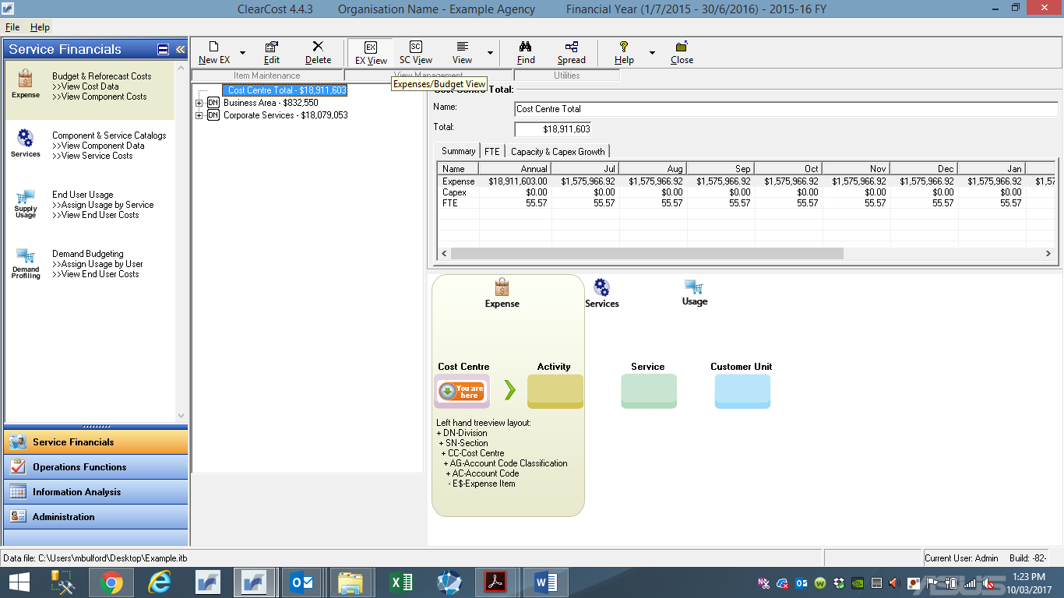

2. To add a new expense item, select **NEW EX** button – ensure that Expense Item is selected.

The Add Expense Item window will display.

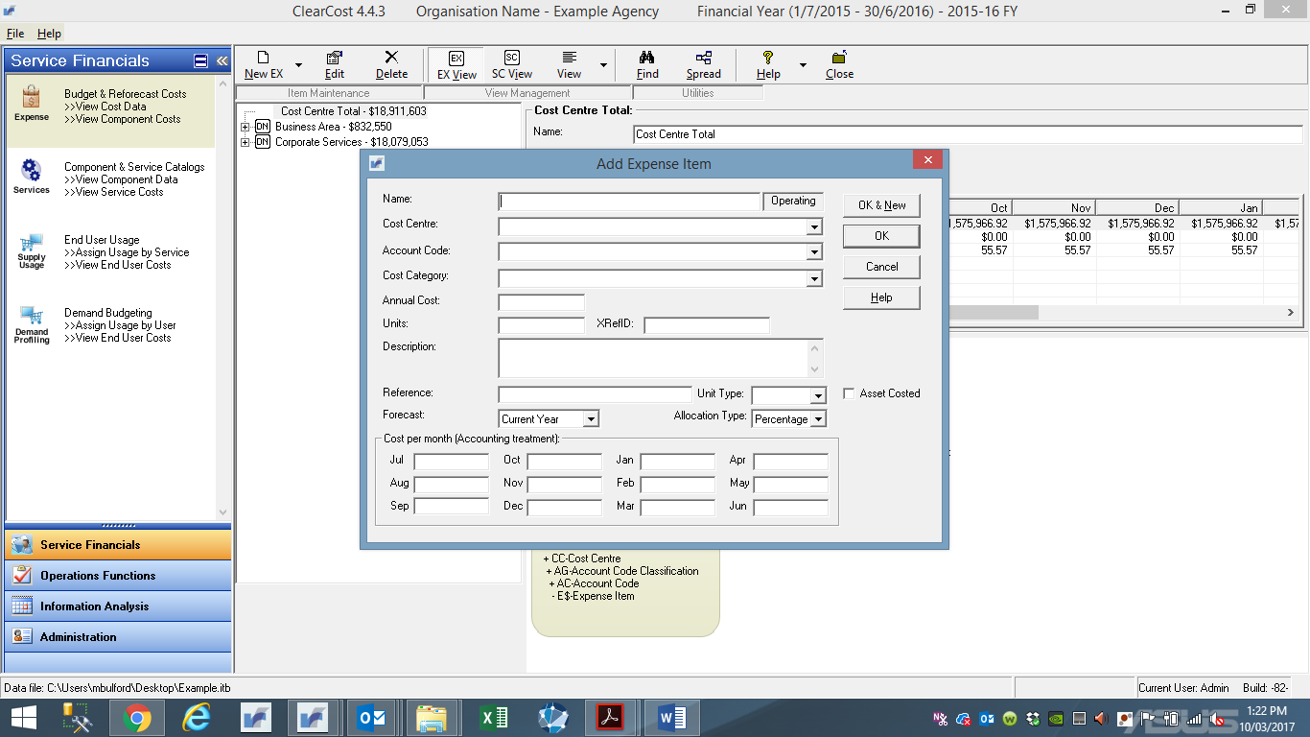

3. Enter values in the fields as follows:

* In the **Name** field, enter a label for the expense item. Up to 50 characters can be entered, with any combination of alphabetic, number, hyphen and space characters. To move to the next field, press the [Tab] key. The name field should have enough information to uniquely identify an item, with best practice to use the naming conventions in your agency in accordance with FMIS whenever possible.

Please note, no other expense item within a Cost Centre and Account Code can have the same name. The default for the Name will be the Account Code Name.

* From the **Cost Centre** drop-down list, select the Cost Centre to which the expense item belongs. This Cost Centre is the one which expenditure will be recorded against.
* From the **Account Code** drop-down list, select the Account Code to which the expense item relates (refer to Section 3 in relation to Setting up Account Codes).
* From the **Cost Category** drop-down list, select the category to which the expense will be allocated. This decision will be determined by your aAgency’s use of this custom field.

Selecting a ‘Staff’ related Cost Category (i.e. Consultants, Contractor Costs, and Employee Costs) will flag to the system this Expense may have headcount implications. The following additional information is displayed in the Expense form when this occurs.

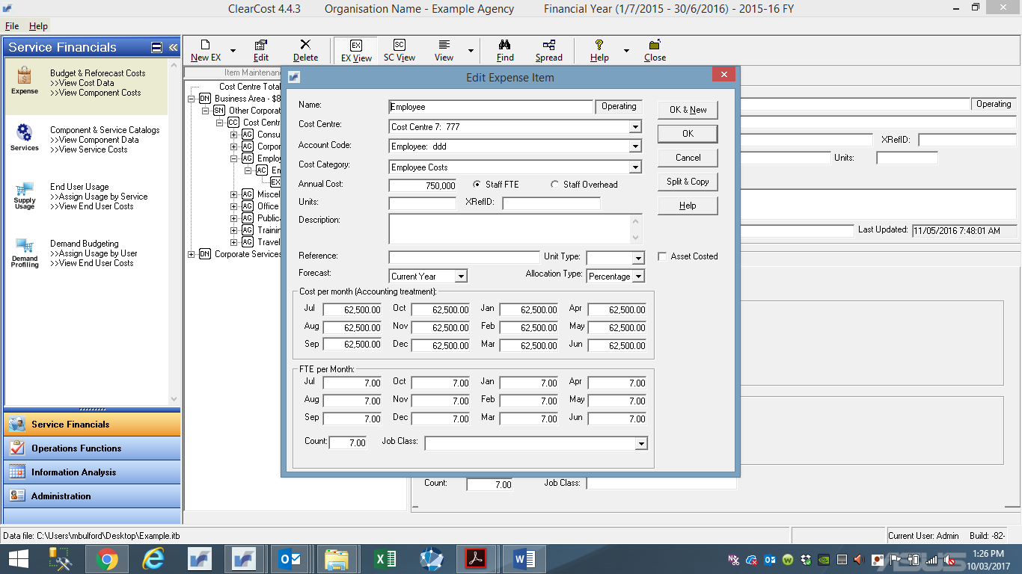

* **Staff FTE** (Full Time Equivalent) defines the expense item as representing a person. The **FTE per Month** frame is displayed, allowing you to enter the headcount by month or as an annual figure under the **Count** box, the average annual FTE figure is calculated by the system.
* **Staff Overhead** defines the expense item as representing ‘on-costs’ or ‘other staff related costs’ (e.g. superannuation, worker’s compensation, long-service leave…etc.).
* The **Units** field – **DO NOT USE**.
* The **XRefID** field may be used as a link for General Ledger expense mapping by the separately licensed GL Load Utility – **DO NOT USE.**
* In the **Description** field, explain why the item is required, how the value of the item was derived, and any other useful details. This field is important as it explains why the expense item was included in the budget.
* The **Reference** field is an additional descriptor field. It allows separation of descriptive data (e.g. it may store the Payroll Number or Job Level descriptor for staff members).
* The **Unit Type** defines what 'time-based' Unit Type reference will be used for time based allocations of this Staff Expense – **DO NOT USE.**
* The **Allocation Type** defines either Percentage as the method to allocate the Expense by or Units (of time). If Units, then you must choose a **Unit Type**. The Model will default to Percentage. **DO NOT CHANGE**
* The **Asset Costed** checkbox flags this Expense as one with amounts generated via the Asset Module (if used). For the purposes of this Manual and model development the Asset Module is not used.
* To enter the financial value of this expenditure item, either:
* enter the total amount of the expenses in the **Annual Cost** field; or
* in the **Cost per Month** frame, enter the specific amounts in the appropriate months. Use this method if you have large amounts of expenditure occurring in specific months (to assist organisational cashflow management) or if you have a time dependent expense (such as a new employee or consultant beginning in a specific month). The system automatically calculates values for these 12 fields when the **Annual Cost** value is supplied; or

4**.** When you have completed all fields, you can either click **OK & New** to save the item’s details and to add a new expense item, or click **OK** to save the item’s details and return to the Expense Items window.

The tree-view will redisplay with the updated values and totals.

## Editing Items

Use this procedure to edit an existing expense item.

1. On the Main Menu categories, click **Budget & Relocation Costs** and ensure that **Expense/Budget View** is selected. The Expense window will display, showing the default tree-view.

2. Select the item by clicking on the name. With the expense item icon highlighted in the tree-view, details will display in the right-hand window. You can select either the **Expense Phasing** or the **Expense Allocation** data view to review.

3. To edit any information in the Expense item, click the **Edit** button on the toolbar.

The Edit Expense Item window will display.

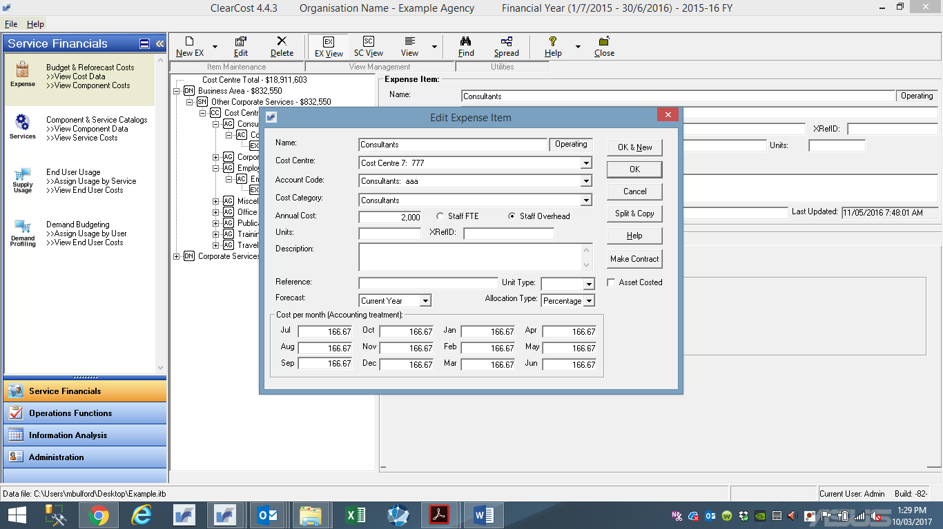

4. Update the required fields by overtyping or selecting new field values from drop-down lists.

5. When you have completed all fields either, click **OK & New** to save the item’s details and to add a new expense item, or click **OK** to save the item’s details and return to the Expense Items window.

6. The tree-view will redisplay with the updated values and totals.

7. The system ensures that you cannot operate on any other values until you have completed updating the item fields and selected **OK or Cancel**.

## Deleting Expense Items

Use this procedure to delete an expense item.

**Procedure**

1. On the Main Menu categories, click **Budget & Relocation Costs** and ensure that **Expense/Budget View** is selected. The Expense window will display, showing the default tree-view.

2. To find the expense item for deletion use the tree-view to locate the item.

3. With the expense item icon highlighted in the tree-view, click the **Delete** button on the toolbar.

* If the database had ‘committed expenditure’, then you cannot Delete an Expense, only clear the amounts. The following message is displayed in this case.



* If the database had ‘committed expenditure’ and has Forecast Expenses, then you cannot Delete an Expense, only clear the amounts. The following message is displayed in this case.



* If none of the above conditions apply, a message will display asking if you are sure you want to delete the item.



4. To delete the item, click **Yes**. Otherwise, click **No**. The tree-view will redisplay with the updated values and totals.

# Allocating Expenses to Activities

Activity costing is a translation of the financial budget into three discrete but sequential groupings. First step is Activity costing, second is the Service (corporate services) costing, and third is the Unit Costing (cost allocation). This Section contains the procedures to arrive at the first of these outcomes.

For the Exercise, the process of allocating expenses to activities will be completed by agencies through the completion of surveys. The driver will be percentage (%) of time and effort of the workforce for each cost centre in performing pre-determined tasks. A standard set of activities will be provided with the survey templates, aligning with the Survey Catalogue, along with an ‘other’ category for agency specific corporate activities not captured in the catalogue.

**Please note that completed surveys will be uploaded into ClearCost by Synergy**. Accordingly, the following Sections are incorporated into this Manual to provide transparency in the processes that may allow a user to change allocations should there be a requirement after the collection and input of completed surveys into ClearCost.

## Adding Expense to Activity Allocations

Use this procedure to allocate an expense item to one or more predefined Activities.

**Before you start**

Review the list of Activities. These are the categories to which every expense item must be allocated to. This list is maintained by the Department of Finance in the Corporate Business Services Catalogue. You will need to determine which Activities apply to each expense item, as well as the percentage of the allocations. This will be determined through the survey process for each cost centre.

Please note, that an Expense Item must be created before you can perform any Activity Allocations.

**Procedure**

1. On the Main Menu categories, click **Budget & Reforecast Costs** and ensure that **Expense/Budget View** is selected. The Expense window will display, showing the default tree-view.

2. To find the expense item that you want to add Activity allocations to, either use the **Find** function or use the tree-view to locate the item.

Select the item by clicking on the name. With the expense item icon highlighted in the tree-view, details will display in the right-hand window. You can select either the **Expense Phasing** or the **Expense Allocation** data view to review.

3. Click on the **Expense Allocation** tab. This will show you the current Expense allocations for this item (if any).

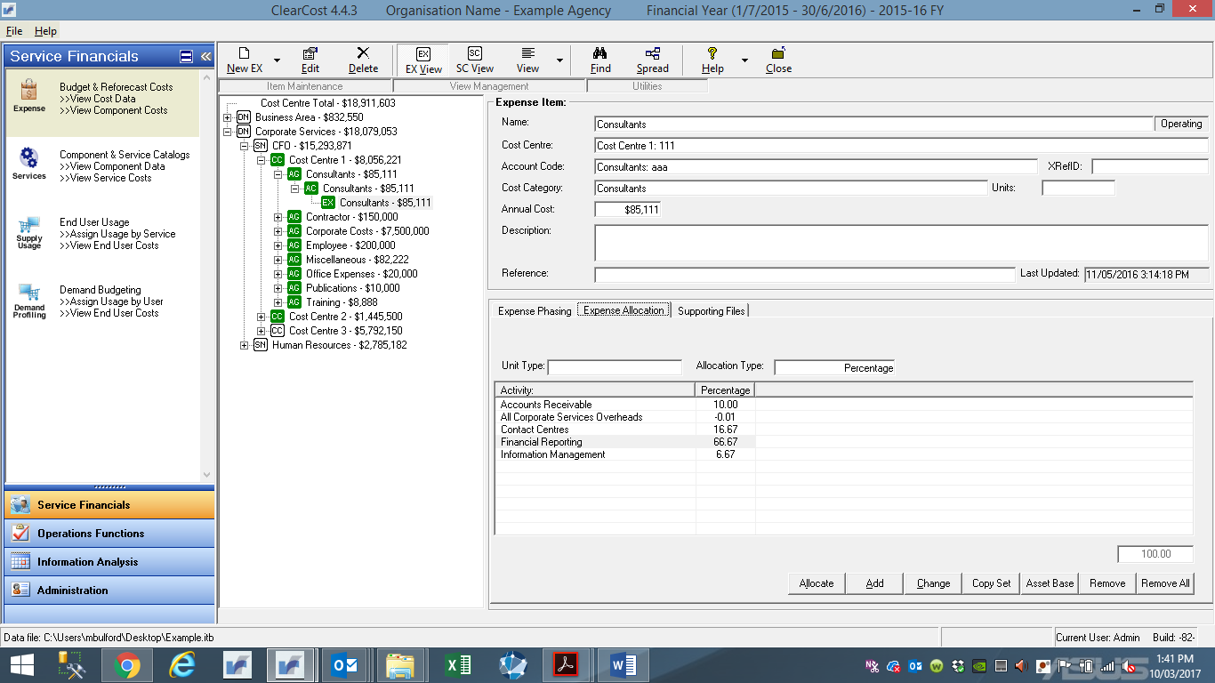

4. There are two methods to allocate an Expense to an Activity. One uses the **Allocate** button, the other uses the **Add** button.

* **Allocate** presents a tree-view map of all Activities (easy to find what you are looking for) and allows for multiple selections in the one pass.
* **Add** assumes you know the Activity you want and presents a simple dropdown list of all available Service Components to choose from.

5. To add new allocations using the Allocate button, click that button.

The Assign Activities window will display.

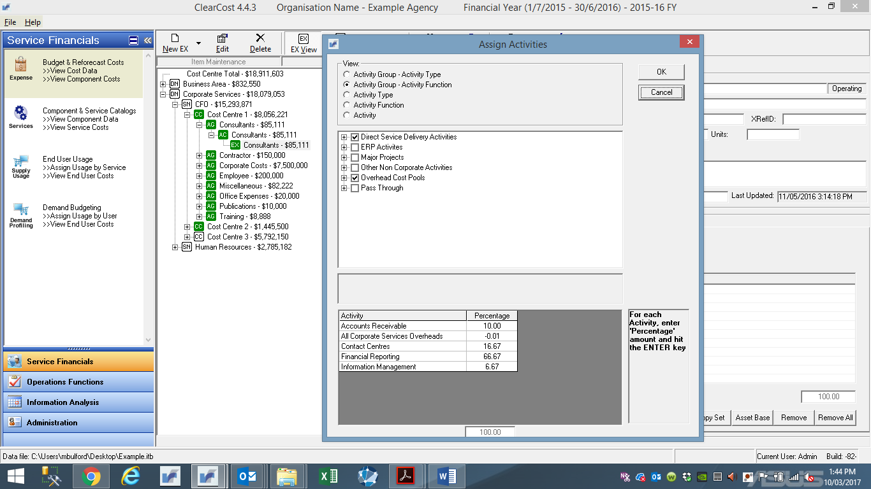

* The View section allows you to tailor the way the tree-view displays the Activities. Click the appropriate radio button:
* By Group will display a three (3) level hierarchy of Activities.
* By Type or Classification will display a two (2) level hierarchy of Activities.
* The last option will display a simple list of all Activities.
* To select Activities, click in the box adjacent to the name, this will show as a tick in the box and will add the name to the list at the bottom of the window. You can deselect the name by clicking the box again, this will remove the tick form the box and remove the name from the list.
* Once you have selected the Activities, you must identify the allocation % to assign to each one:
* Click in the **Percentage** field to the right of the Activity name in the bottom of the window.
* Type the % (e.g. 25 for 25%).
* Repeat that process until all Activities have an allocation. You should continue to allocate the item until the total percentage is 100%.
* Click the **OK** button at the top right of the window when you have finished with the allocations for the Expense.
* If you wish to abort the allocation process for this Expense, hit the **Cancel** button.

6. To add a new allocation click the **Add** button on the Service Allocation tabbed window.

The Select Activity window will display.

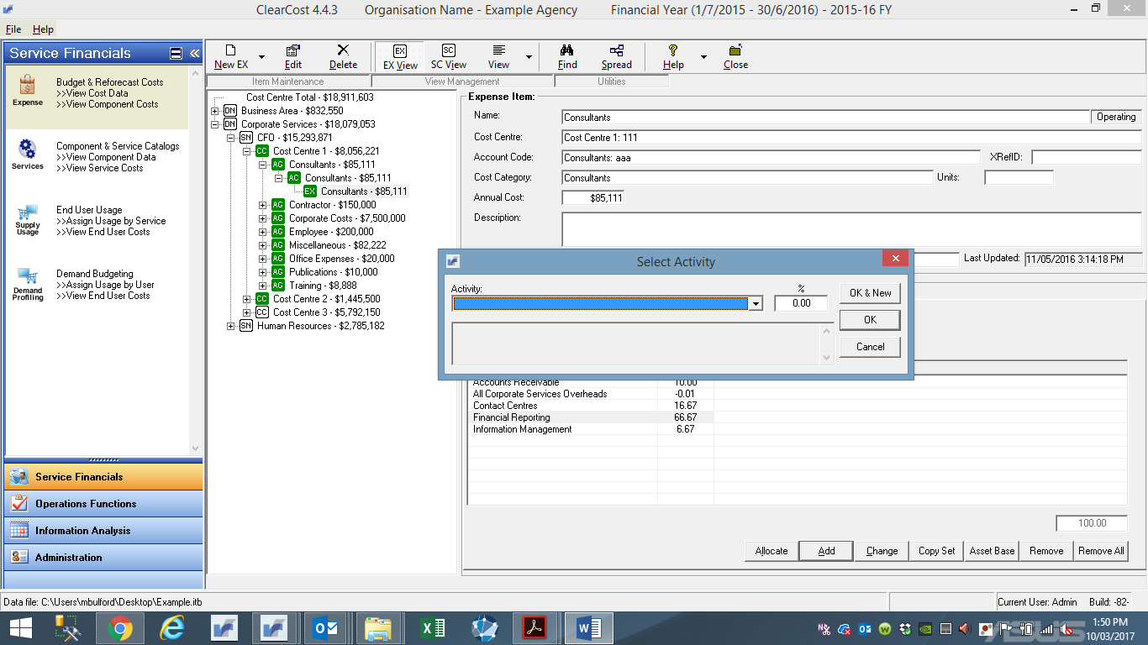

* From the **Activity** drop-down box, select a pre-determined Activity. You may select the Activity using the drop-down button and clicking on the required activity, by pushing the up-arrow and down-arrow keys on the keyboard to cycle through the list of components, or by typing the first letter of the name and cycling through until the desired one is displayed.
* In the **%** field, enter the percentage of this expense attributable to the selected Activity. The percentage must be entered as a number. For example, 10% will be entered as **10** or **10.00**
* When you have completed both fields, either:
* click **OK & New** – save allocation and make further allocations with this expense item or
* click **OK** – save allocation and return to the Expense Items window.

The Activity tab will redisplay showing the current allocations and percentages. The **Total %** field shows the total of all allocations for this expense item.

* You should continue to allocate the item until the total percentage is 100%.

**Tip:** If you are not sure of the correct allocation, leave the item at more than or less than 100%. Using the balancing function of the system, this item will appear as unbalanced - marked for later review (shown as a **red** in colour on the tree-view). Once you have completed as many allocations against the expense items as possible, you can view any remaining items with incomplete allocations. Any items that have Activity allocations that do not total 100% will be displayed in red, whereas expenses with no allocations are shown as white.

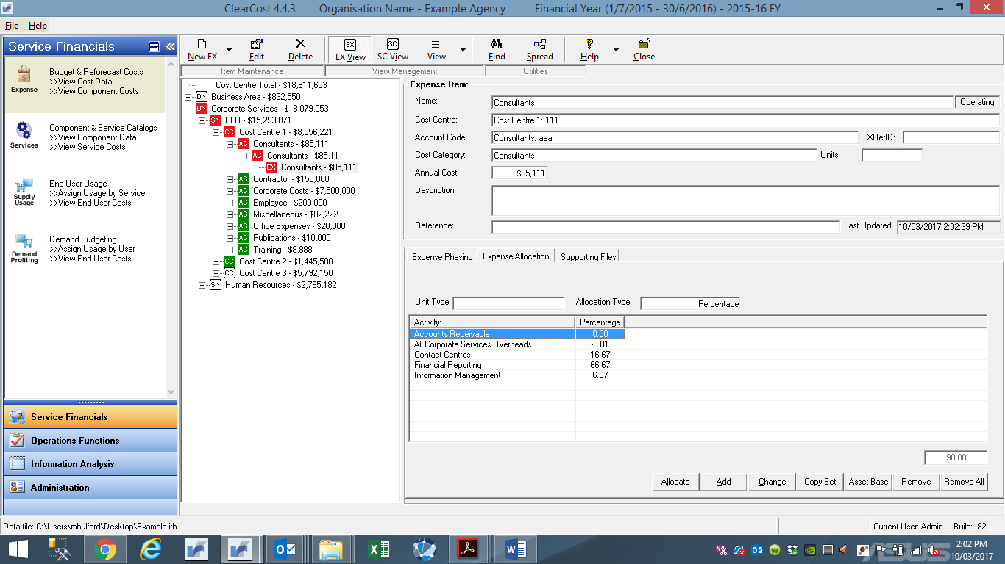

## Changing Expense to Activity Allocations

Use this procedure to edit the percentage of an Expense Item allocated to Activities.

**Procedure**

1. On the Main Menu categories, click **Budget & Reforecast Costs** and ensure that **Expense/Budget View** is selected. The Expense window will display, showing the default tree-view.

2. To find the expense item that you want to add Activity allocations to, either use the **Find** function or use the tree-view to locate the item.

3. Click on the **Expense Allocation** tab of the selected expense item, if this is not already selected.

4. Click on the Expense that you want to alter, and click the **Change** button on the Activity window.

The Enter Allocation Amount window will display.

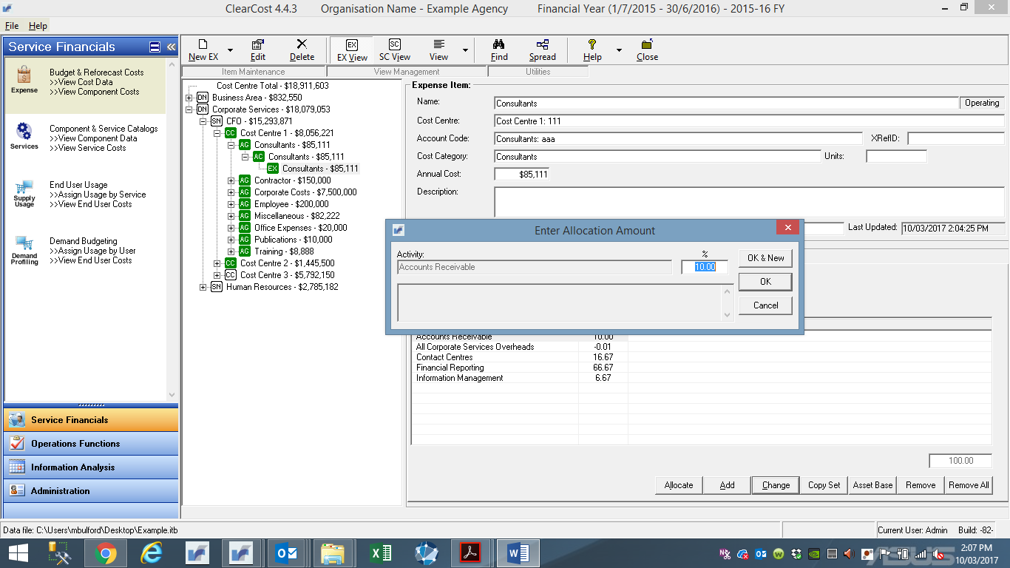

5. Enter the revised percentage in the **%** field.

6. Click **OK** (or the **Cancel** to abort the process). The **Expense Allocation** window will redisplay showing the current allocations and percentages.

**Tip:** If you are not sure of the correct allocation, leave the item at more than or less than 100%. Using the balancing function of the system, this item will appear as unbalanced - marked for later review (shown as a **red** in colour on the tree-view). Once you have completed as many allocations against the expense items as possible, you can view any remaining items with incomplete allocations. Any items that have Activity allocations that do not total 100% will be displayed in red, whereas expenses with no allocations are shown as white – refer to Section 2.4.

## Copy Activity Allocation Sets

Use this procedure to copy an activity set of allocations from one expense item to another. This is used when creating multiple expense items with similar activity allocations to existing expense items in that same organisation unit or cost centre (e.g. staff in the same functional area).

**Procedure**

1. On the Main Menu categories, click **Budget & Reforecast Costs** and ensure that **Expense/Budget View** is selected. The Expense window will display, showing the default tree-view.

2. To find the expense item that you want to add Activity allocations to, either use the **Find** function or use the tree-view to locate the item.

3. Click on the **Expense Allocation** tab of the selected expense item, if this is not already selected.

4. Should an Expense Allocations exist, you may want to delete these (refer to Section 6.4). Otherwise copied allocations will be appended to the current list.

5. To copy another expense item’s allocations, click on the **Copy** button on the **Expense Allocation** window of the target item.

A window will display listing all expense items in the Cost Centre.

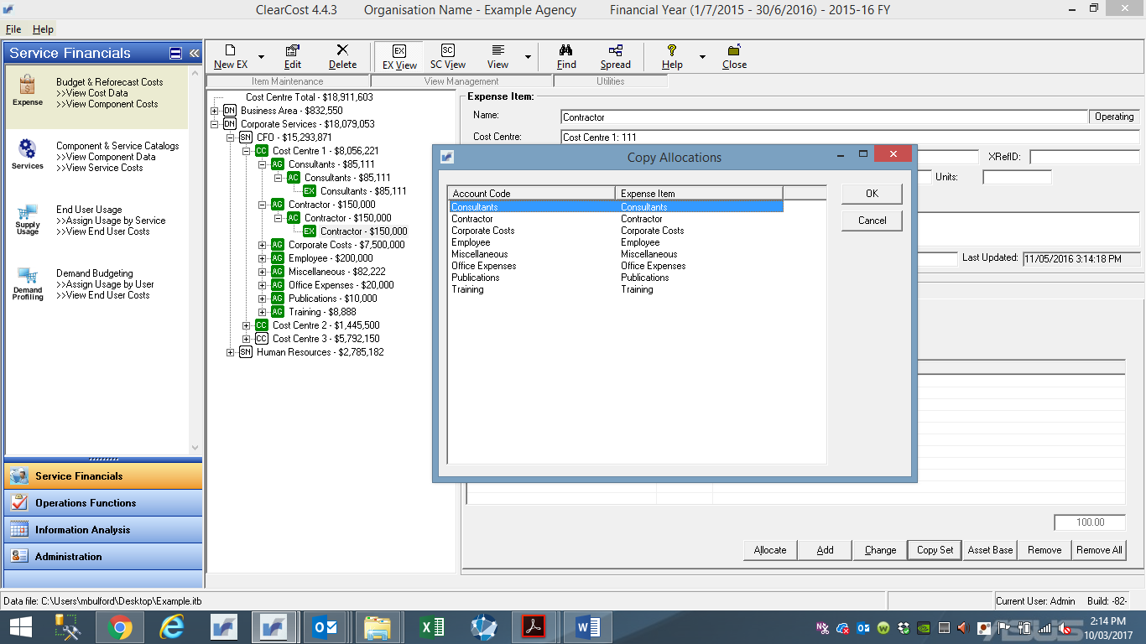

Select the source Expense Item and click **OK**. The allocations from the source item will be added to the current list of allocations for the target item.

6. The **Expense Allocation** window will redisplay showing the current allocations and respective percentages.

## Remove Expense to Activity Allocations

Use this procedure to remove an activity allocation from an expense item.

**Procedure**

1. On the Main Menu categories, click **Budget & Reforecast Costs** and ensure that **Expense/Budget View** is selected. The Expense window will display, showing the default tree-view.

2. To find the expense item that you want to remove Activity allocations to, either use the **Find** function or use the tree-view to locate the item.

3. Click on the **Expense Allocation** tab of the selected expense item, if this is not already selected.

4. Two methods exist to remove allocations:

* To remove just one allocation, click on the Activity that you want to remove, and click the **Remove** button on the Expense Allocation window.

A message will display asking if you want to delete the allocation to this Activity.

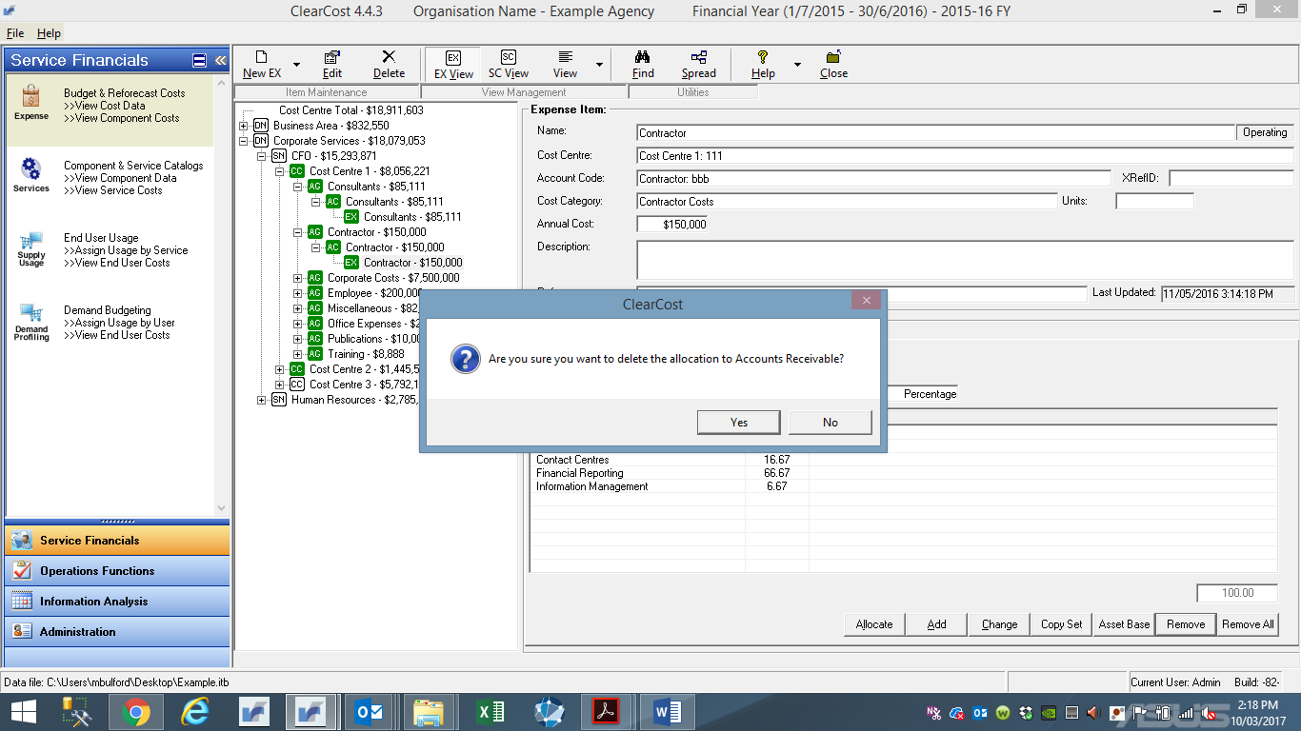

Click **Yes** to proceed or **No** to abort the deletion.

* To remove all allocations for that expense item, click the **Remove All** button on the Expense Allocation window.

A message will display asking if you want to delete all allocations for this Expense Item.

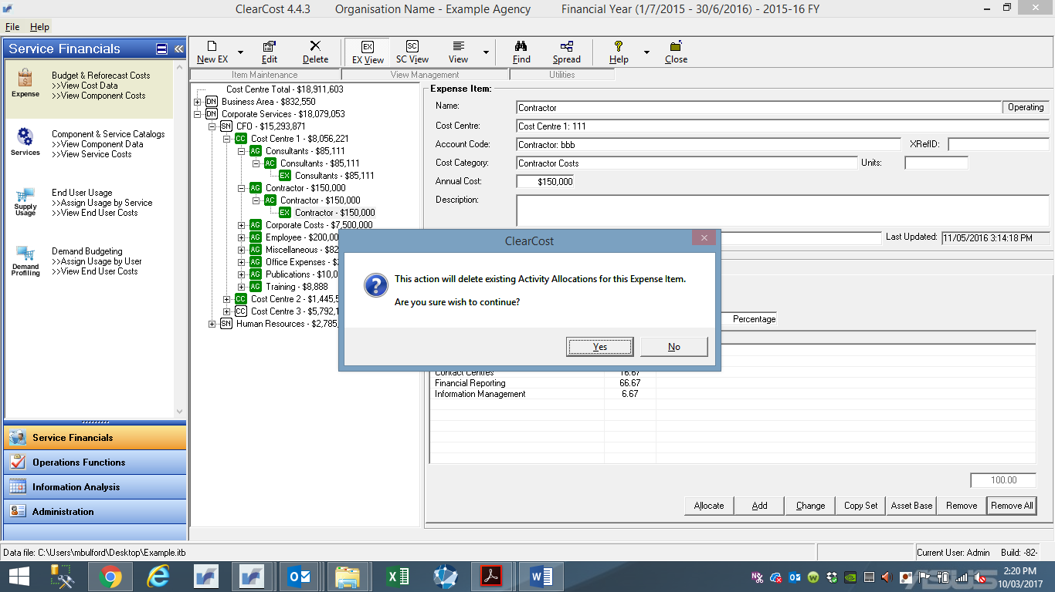

Click **Yes** to proceed or **No** to abort the deletion.

5. The **Expense Allocation** window will redisplay showing the current allocations and respective percentages.

# Allocating Activities to Services

Activity costing is a translation of the financial budget into three discrete but sequential groupings. First step is Activity costing, second is the Business Service (corporate services) costing, and third is the Unit Costing (cost allocation). This Section contains the procedures to arrive at the second of these outcomes.

The mapping of activities to services will be pre-determined and pre-populated within ClearCost, aligning to the Service Catalogue. Allocations should between activities and service **ARE** **NOT TO BE CHANGED**. In general, most activities will be mapped automatically to specific services (on a one-to-one basis). However, there will be cost-pool activities (such as overheads, major projects…etc.) that will require input by Users in assigning activities to multiple services (on a one-to-many basis).

For benchmarking purposes, the quantity of ASL allocated to activities will be the driver and **ARE NOT TO BE CHANGED** until discussions and confirmation from Synergy has been obtained. This will ensure that all agencies are using and applying a similar methodology in the allocation of activities to services.

Section 7.5 will provide the User with the procedure required to allocate Overheads to the predefined Services and shall be completed only after all other direct allocations (one-to-one) have been finalised.

## Finding Activities

Use this procedure to find an existing Activity. ClearCost offers two methods of finding an item. You may either browse using the tree-view or search directly using the **Find** function. You can search for an item based on any part of its name or another nominated field. This provides you with a quick method of honing in on a specific Activity you wish to review or modify.

**Procedure**

1. On the Main Menu, click **Components & Service Catalogs**. The Activity window will display, showing the default **Activity** tree-view.

2. Click the **Find** button on the toolbar.

The Find window will display.

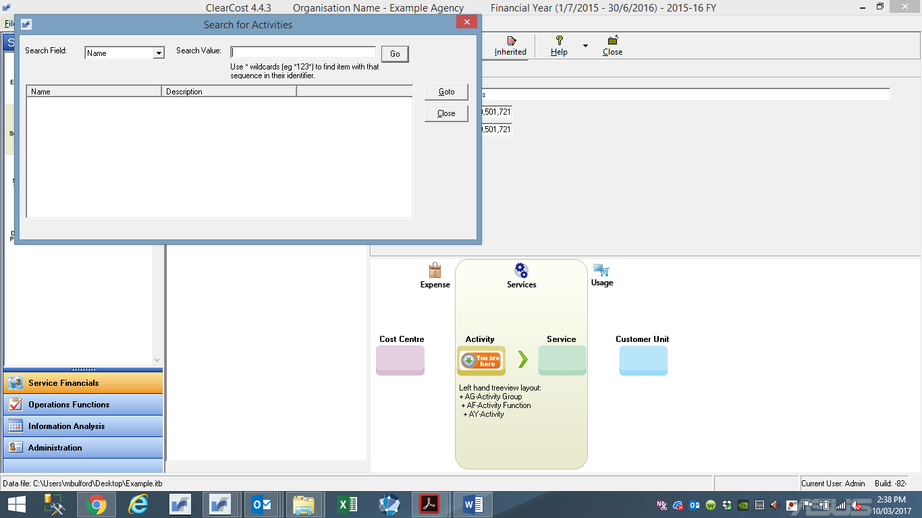

3. Select the **Search** field you wish to look in (either Name or Description)

4. Enter the Search Value you are seeking. Enter a full or part word from the Name of the item, then click on the **Go** button. This will display any matches.

5. If only one Item is found, that item will be displayed in the main tree-view. Otherwise the list of possible matches is displayed in the results box. For multiple matches, select the entry from the results list (highlight it) and hit the **Goto** button.

6. To end the **Find** function without viewing any results, click the **Close** button

7. The next time you use **Find**, it will remember your last search result.

## Adding Activities Allocations to Services

Use this procedure to allocate an Activity to one or more predefined Services.

**Before you start**

You should start by reviewing the list of Services sourced from the Service Catalogue. You will need to determine which Activities apply to each Service, as well as the percentage of the allocations. Most Activities will be assigned to Services on a one-for-one basis and will easily be identified within the Service Catalogue. Accordingly, adding, changes to, or copying Activity allocations to Services (Section 7.2, 7.3, and 7.4) will rarely be utilised during the benchmarking Exercise.

**Procedure**

1. On the Main Menu, click **Component & Service Catalogs** and ensure that **Activity View** is selected. The Activity window will display, showing the default **Activity** tree-view.

2. To find the Activity that you want to add Services allocations to, either use the **Find** function or use the tree-view to locate the item.

Select the item by clicking on the name. With the activity item icon highlighted in the tree-view, details will display in the right-hand window. You can select either the **Allocated To**, **Contributing Expenses**, or the **Monthly Total** data view to review.

3. Click on the **Allocated To** window. This will show you the current Activity allocations for this item (if any).

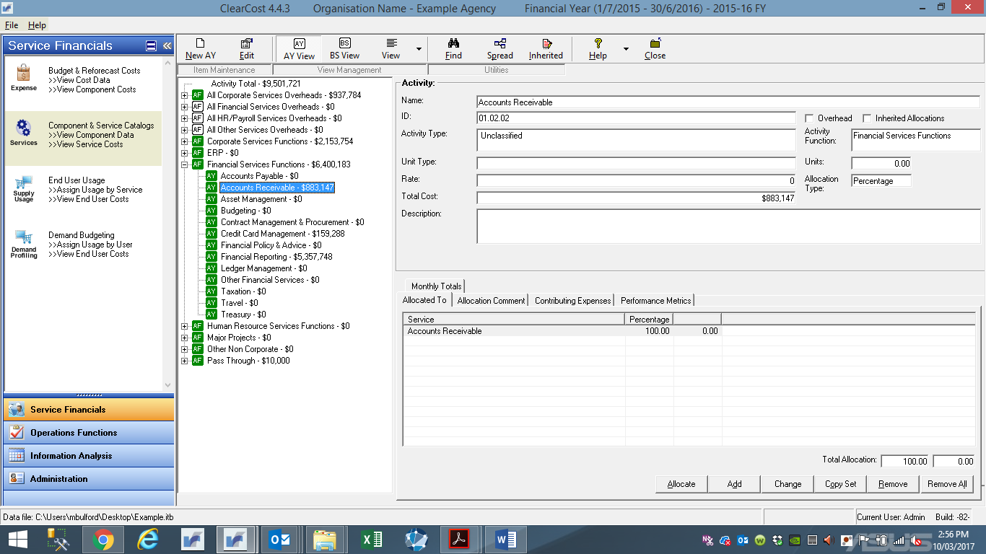

4. There are two methods to allocate an Activity to a Service. One uses the **Allocate** button, the other uses the **Add** button.

* **Allocate** presents a tree-view map of all Services (easy to find what you are looking for) and allows for multiple selections in the one pass.
* **Add** assumes you know the Service you want and presents a simple dropdown list of all available Services to choose from.

5. To add new allocations using the **Allocate** button, click that button.

The Assign Services window will display.

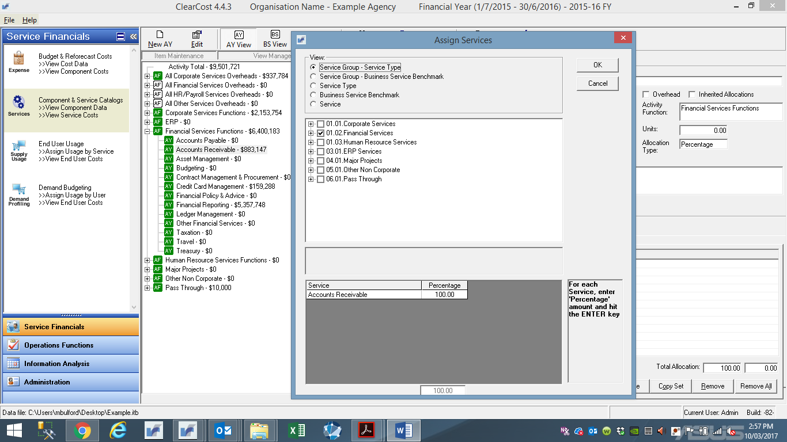

* The View section allows you to tailor the way the tree-view displays the Services. Click the appropriate radio button:
* By Group will display a three (3) level hierarchy of Services.
* By Type or Benchmark will display a two (2) level hierarchy of Services.
* The last option will display a simple list of all Service.
* To select Services, click in the box adjacent to the name, this will show as a tick in the box and will add the name to the list at the bottom of the window. You can deselect the name by clicking the box again, this will remove the tick from the box and remove the name from the list.
* Once you have selected the Services, you must identify the allocation % to assign to each one:
* Click in the **Percentage** field to the right of the Service name in the bottom of the window.
* Type the **%** (e.g. 25 for 25%).
* Repeat that process until all Services have an allocation. You should continue to allocate the item until the total percentage is 100%.
* Click the **OK** button at the top right of the window when you have finished with the allocations for the Activity.
* If you wish to abort the allocation process, hit the **Cancel** button.

6. To add a new allocation click the **Add** button on the **Allocated To** window.

The Add Service Allocation window will display.

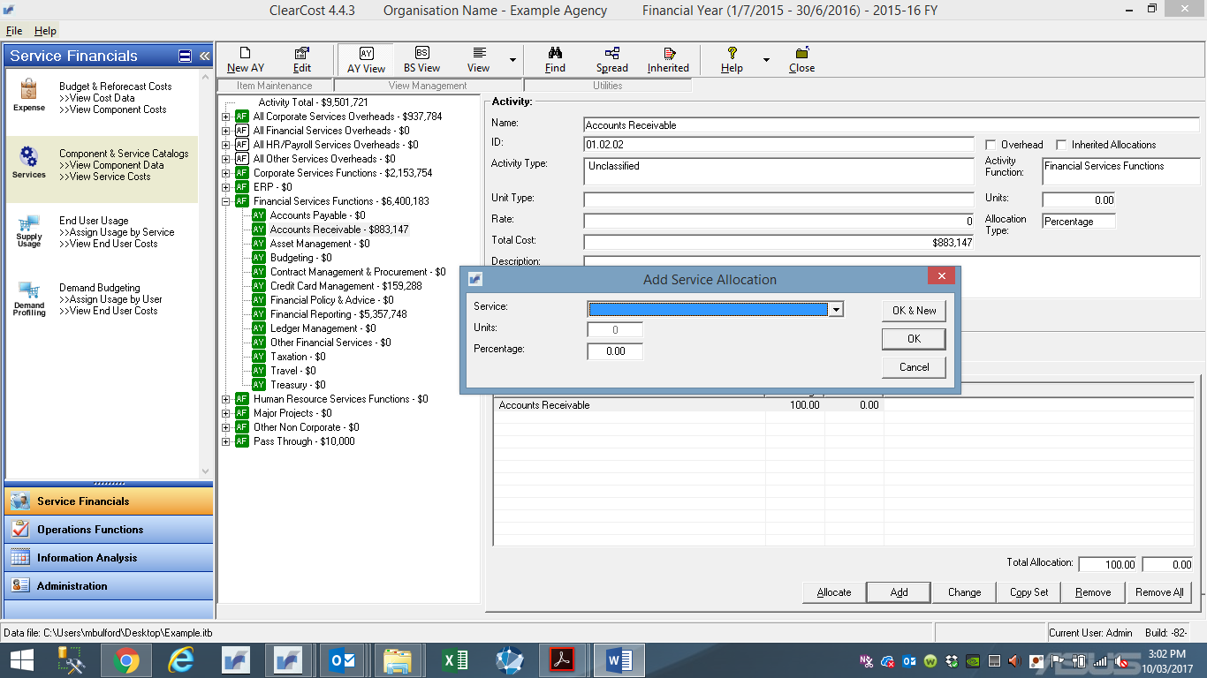

* From the **Service** drop-down box, select a pre-determined Service. You may select using the drop-down button and clicking on the required item, by pushing the up-arrow and down-arrow keys on the keyboard to cycle through the list of, or by typing the first letter of the Service name and cycling through names until the desired one is displayed.
* Either: (1) In the **%** field, enter the percentage of this expense attributable to the selected Service. The percentage must be entered as a number. For example, 10% will be entered as **10**; or (2) In the **Unit** field, enter the unit amount for this allocation.
* When you have completed both fields, either:
* click **OK & New** – save allocation and make further allocations with this expense item or
* click **OK** – save allocation and return to the Expense Items window.

The **Allocated To** tab will redisplay showing the current allocations and percentages. The **Total %** field shows the total of all allocations for this expense item.

* You should continue to allocate the item until the total percentage is 100%.

**Tip:** If you are not sure of the correct allocation, leave the item at more than or less than 100%. Using the balancing function of the system, this item will appear as unbalanced - marked for later review (shown as a **red** in colour on the tree-view). Once you have completed as many allocations against the expense items as possible, you can view any remaining items with incomplete allocations. Any items that have Activity allocations that do not total 100% will be displayed in red, whereas expenses with no allocations are shown as white – refer to Section 2.4.

## Changing Activity Allocations

Use this procedure to edit the percentage of an Activity allocation to a Service.

**Procedure**

1. On the Main Menu, click **Component & Service Catalogs** and ensure that **Activity View** is selected. The Activity window will display, showing the default **Activity** tree-view.

2. To find the Activity that you want to add Services allocations to, either use the **Find** function or use the tree-view to locate the item.

3. Click on the **Allocated To** window. This will show you the current Activity allocations for this item (if any).

4. Click on the Activity that you want to alter, and click the **Change** button on the Allocated To window.

The Edit Service Allocations window will display.

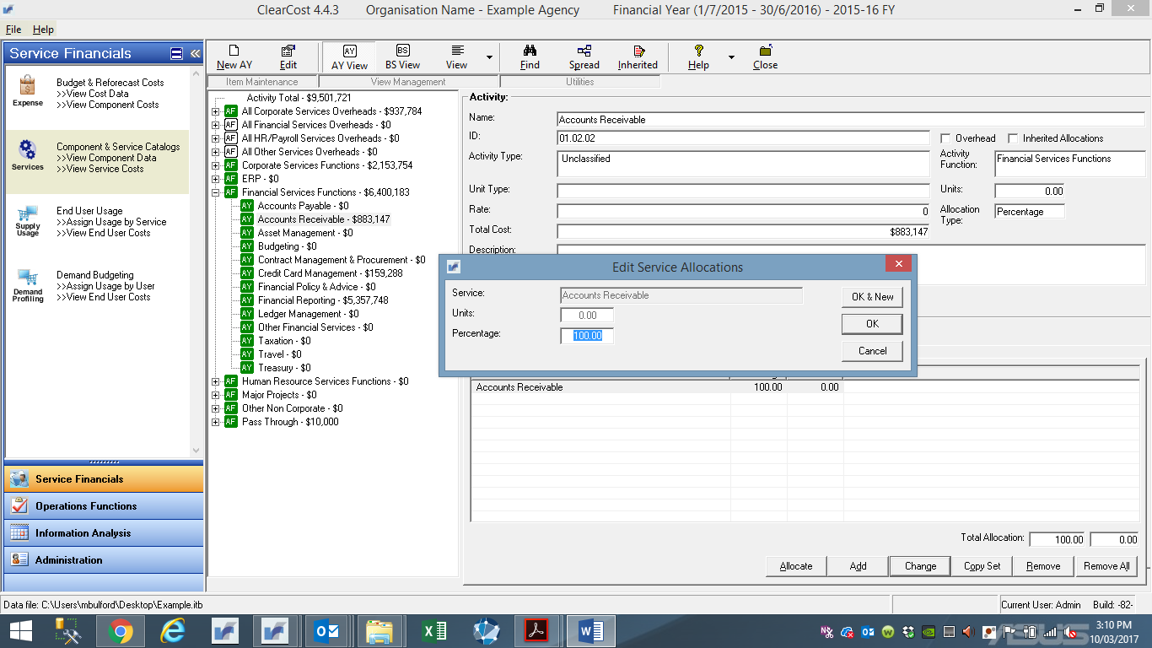

5. Enter the revised percentage in the **%** field.

6. Click **OK** (or the **Cancel** to abort the process). The **Allocated To** window will redisplay showing the current allocations and percentages.

## Copy Service Allocation Sets

Use this procedure to copy a service allocation set from one activity to another.

**Procedure**

1. On the Main Menu, click **Component & Service Catalogs** and ensure that **Activity View** is selected. The Activity window will display, showing the default **Activity** tree-view.

2. To find the Activity that you want to add Services allocations to, either use the **Find** function or use the tree-view to locate the item.

3. Click on the **Allocated To** window. This will show you the Activity allocations for this item (if any).

4. Select an Activity and the details will display in the right-hand frame. Click the **Copy Set** button on the bottom of the right-hand frame.

This will display the list of Activities with existing allocations.

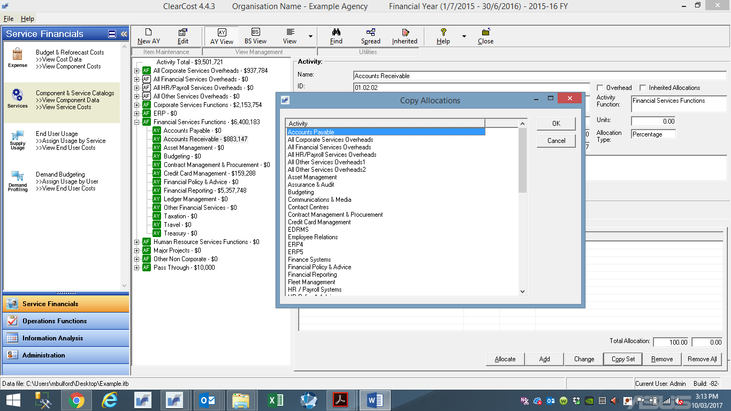

You may want to Delete any existing allocations before copying the new set to this Activity, otherwise you will append the set to the current allocations.

5. Select the Activity whose allocation set you want to copy into this existing Activity and click **OK**.

6. The **Allocated To** window will redisplay showing the current allocations and respective percentages.

## Spread – Overhead Activities to Services

Use this procedure to allocate Overhead Activities (i.e. Corporate, Financial, HR/Payroll, and All Other Services) to Services based on ASL. The following procedure is to be used for these allocations only.

**Before you start**

This procedure is only to be used after all ‘direct’ Activities to Services allocations have been completed, with only **Overhead** cost-pools remaining (the one-to-many activities).

**Procedure**

1. On the Main Menu, click **Component & Service Catalogs** and ensure that **Activity View** is selected. The Activity window will display, showing the default **Activity** tree-view.

2. To find the Activity that you want to add Services allocations to, either use the **Find** function or use the tree-view to locate the item.

3. Click on the **Spread** button on the toolbar. The Automatic Activity Allocations window will display.

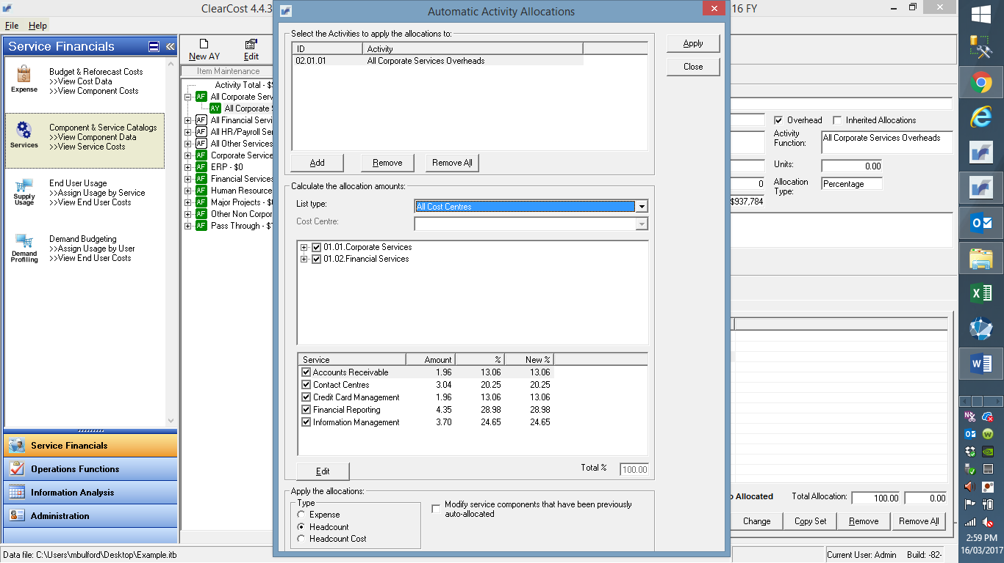

4. In the **Calculate the allocate amounts** frame, select the **List type**. Select **All Cost Centres**. This selection is the default to be used for the Whole-of-Government Benchmarking Exercise. All Cost Centres show the Services contributions/allocations for the entire agency.

5. Once **All Cost Centres** are selected, ensure that **Headcount** is selected on the radio button. This is the default basis for the allocation of overheads to Services.

6. The resulting list of Services that matches your selections (All Cost Centres and Headcount) are shown. You have the option to review and deselect some Services.

7. The **Total %** must equal 100%. As expenses are being sliced and diced in a variety of ways, the final % allocation may not equal 100% (i.e. 99.9% or 100.1% are common). Should this be the case, click **Edit**. The **Edit Allocation Rate** will display.

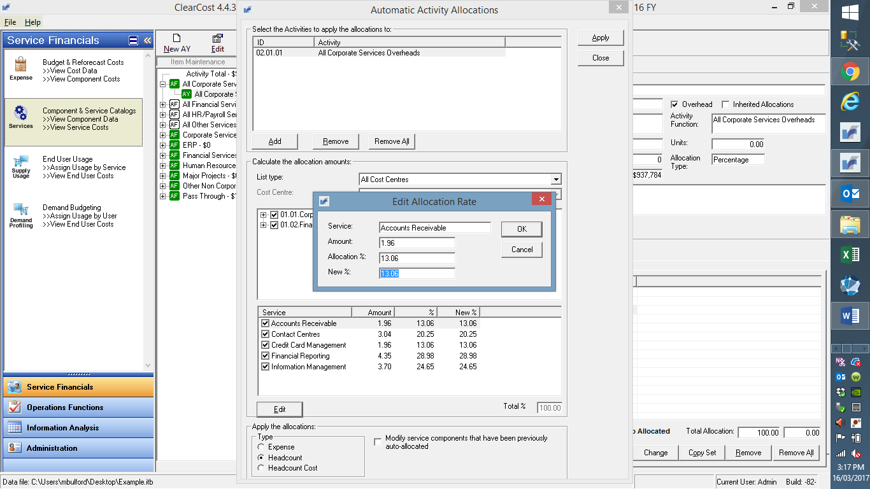

It is best practice to assign the immaterial adjustment to the largest or next largest Service. Click **OK** to confirm or **Cancel** to abort.

8. Once content with the allocations and the Total % is 100%, click the **Apply** button to have these allocations copied to the selected Services.

## Remove Activity to Service Allocations

Use this procedure to remove a service allocation from an activity.

**Procedure**

1. On the Main Menu, click **Component & Service Catalog**. This will display the current list of Activities within a tree-view.

2. To find the activity that you want to remove service allocations to, either use the **Find** function or use the tree-view to locate the item.

3. Click on the **Allocated To** tab of the selected Activity, if this is not already selected.

4. Two methods exist to remove allocations:

* To remove just one allocation, select the Service that you want to remove, and click the **Remove** button Allocated To window.

A message will display asking if you want to delete the allocation to this Service.

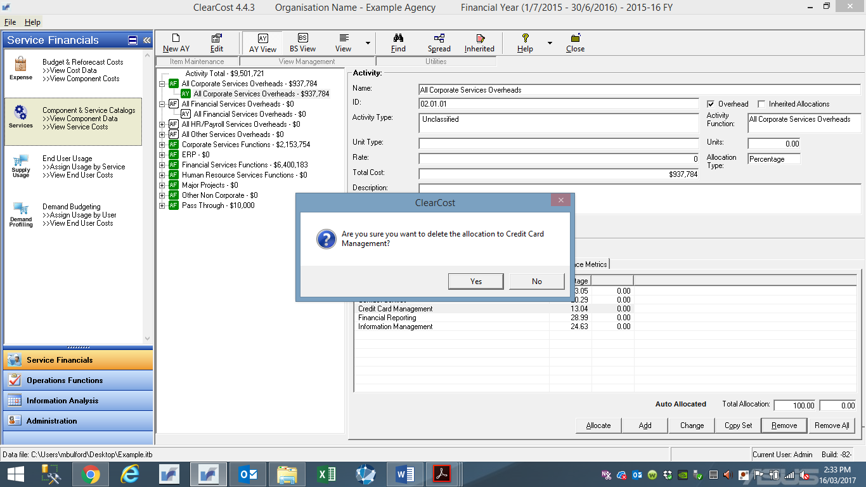

Click **Yes** to proceed or **No** to abort the deletion.

* To remove all allocation entries for a given Activity, hit the **Remove All** button on the Allocated To window.

A message will display asking if you want to delete all allocations for this Activity.

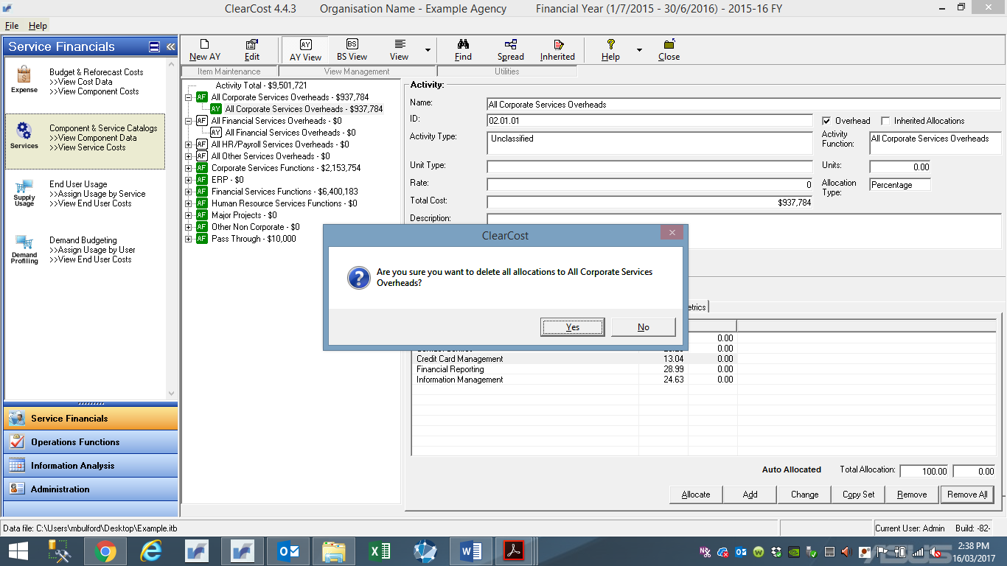

Click **Yes** to proceed or **No** to abort the deletion.

5. The **Allocated To** window will redisplay showing the current allocations and respective percentages.

# Volumetrics (Units)

Activity costing is a translation of the financial budget into three discrete but sequential groupings. First step is Activity costing, second is the Business Service (corporate services) costing, and third is the Unit Costing (cost allocation). This Section contains the procedures to arrive at the third of these outcomes.

Allocating Volumes (Units) to Services

Use this procedure to allocate volumes (units) to Services.

**Before you start**

You should start by reviewing the volumes list on the Service Catalogue. Determine the volumes required for each Service and obtain volumetric data (units) from respective areas.

**Procedure**

1. On the Main Menu, click **End User Usage** and ensure that **Business Services View** is selected.

The Service window will display, showing the default tree-view.

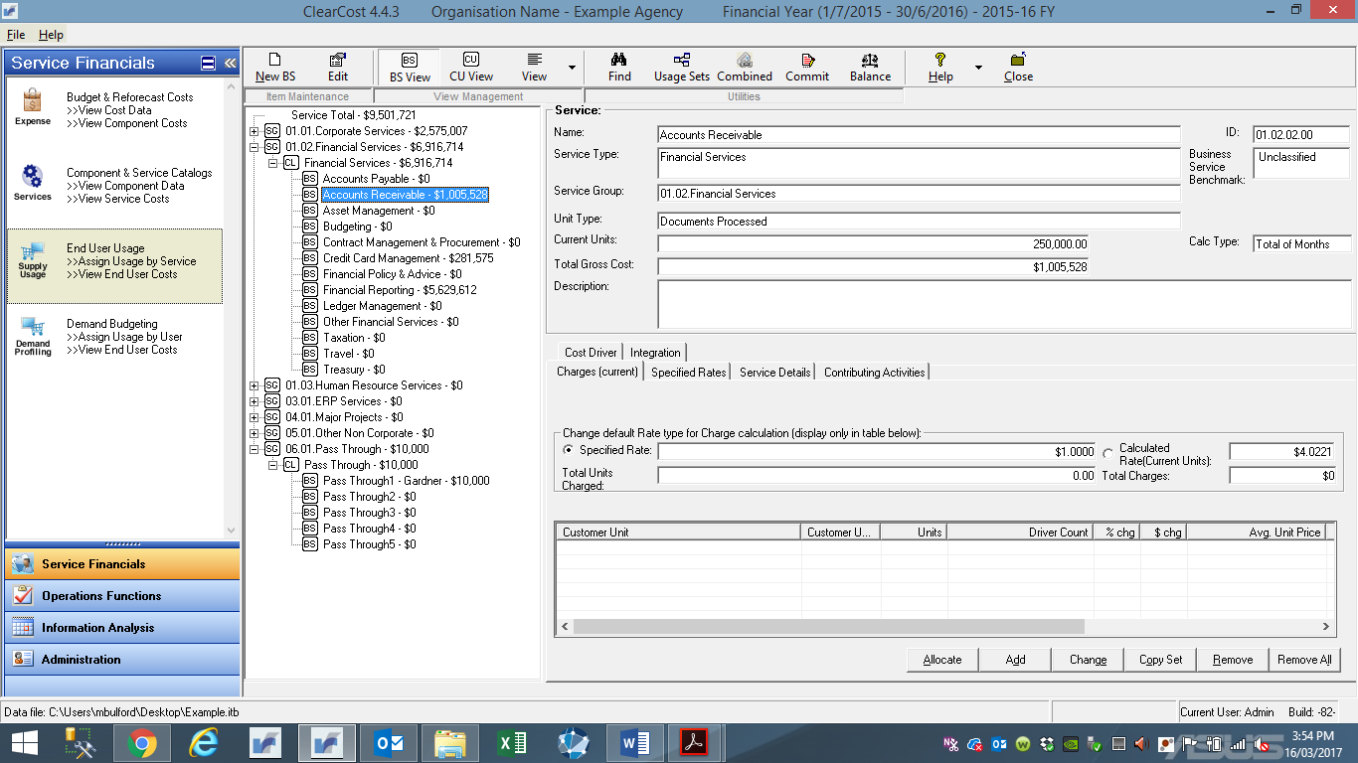

2. To find the Service that you want to assign volumes to, either use the **Find** function or use the tree-view to locate the item. Select the item by clicking on the name. With the Service icon highlighted in the tree-view, details will display in the right-hand window. You will see the **Specified Rate** and **Calculated Rate** in the **Charges (current)** data view – illustrated in above display.

3. Click **Edit**.

The **Edit Services** window will display.

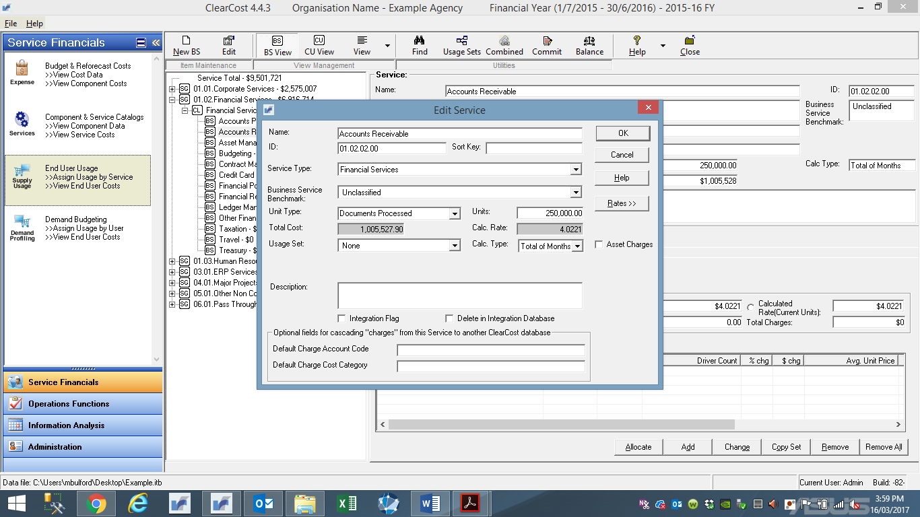

4. In **Unit Type**, use the drop-down box to select the unit type applicable for the Service. This should be defaulted to align with the Service Catalogue. Nevertheless, the User should review to ensure that the correct unit type is selected.

5. In **Units** override the value and input the correct number of units for that Service. ClearCost then calculates the **Calc. Rate** by dividing the total cost by the units which is displayed in the window. Click **OK** to proceed or **Cancel** to abort the process.

## Apply Calculated Rates to Specified Rates

This section describes the function available to copy and rounds the **Calculated Rate** to the **Specified Rate** field across all Services in the database. There are two methods available:

* Commit – which replaces the Specified Rate with the Calculated Rate (total Service cost divided by estimated units of usage)
* Balance – assumes the need to produce a balancing rate that considers charges already applied for Services to Units and uses forecast demand and reforecast costs for the remainder of the year to work out a Rate that will ensure 100% of total re-forecast costs will be recovered (**DO NOT USE**).

**Please note**, every time there is a change to the costs or units of a Service, the Calculated Rate will change automatically within ClearCost. However, the User will be required to update the Specified Rate by clicking on the **Commit** button every time there is a change to cost and allocates to ensure that all reports are updated and displaying correct unit costs.

**Before you start**

The Calculated Rate is the exact rate determined for a Service using the ClearCost calculation (cost divided by units). This may result in a fractional rate (e.g. $134.5723 per unit). The Specified Rate is a manually entered rate for a given Service that is used by ClearCost in all reporting and displays. Usually, the Specified Rate is set to match the Calculated Rate or to ‘round’ the Calculated Rate (e.g. $135 per unit) – both achieved by using the Commit or Balance function available on all Service views.

The Commit function simply copies the Calculated Rate to the Specified Rate for all Services. The Balance function is a variation on the Commit function, used when you have applied the Lock Rate & Lock Units functions (not used for the **Exercise**). Balance will generate a Rate designed to produce a net (zero) recovery balance of charges against cost – by working out the charges to date then determining what Rate is needed for the remainder of the year to achieve the desired 100% cost allocation outcome.

A simple way to think about it – Commit uses ‘estimated’ Units of usage, whereas Balance uses ‘actual’ units of usage by Units to date and their forecast usage for the remainder of the year.

**Procedure**

1. On the Main Menu, click **End User Usage** and ensure that **Business Services View** is selected.

2. To find the Service that you want to update the Specified Rate, either use the **Find** function or use the tree-view to locate the item. Select the item by clicking on the name. With the Service icon highlighted in the tree-view, details will display in the right-hand window. You will see the **Specified Rate** and **Calculated Rate** in the **Charges (current)** data view – refer to illustrations in Section 8.1 display.

3. Click on the **Commit** button.

The **Commit Service Rate** window will display.

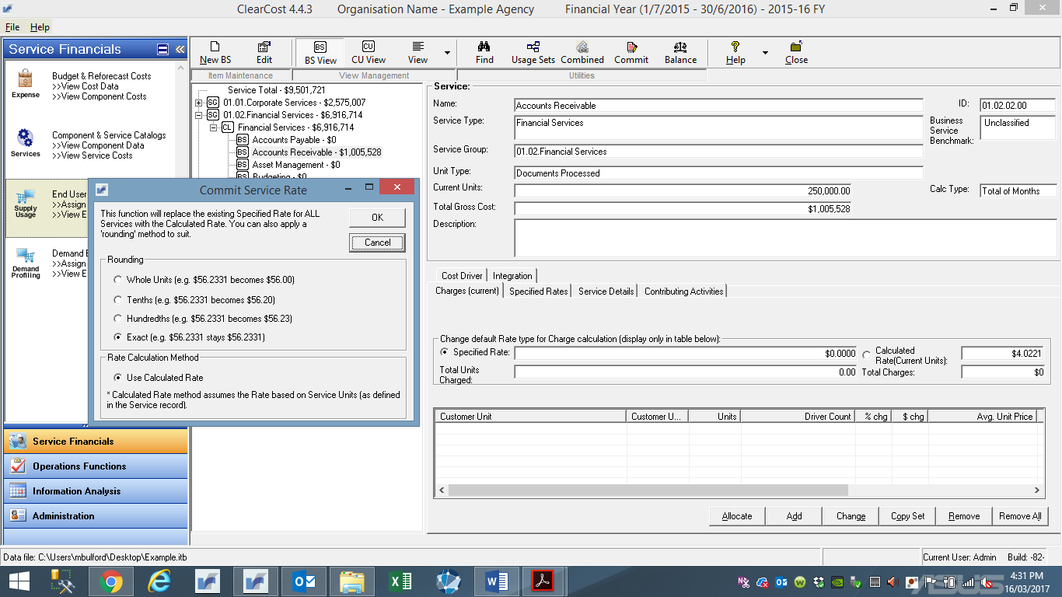

4. To copy the Calculated Rate to the Specified Rate field in Customer Services, select the **Exact** rounding option. Click **OK** to proceed or **Cancel** to abort the process.

A confirmation message will display.

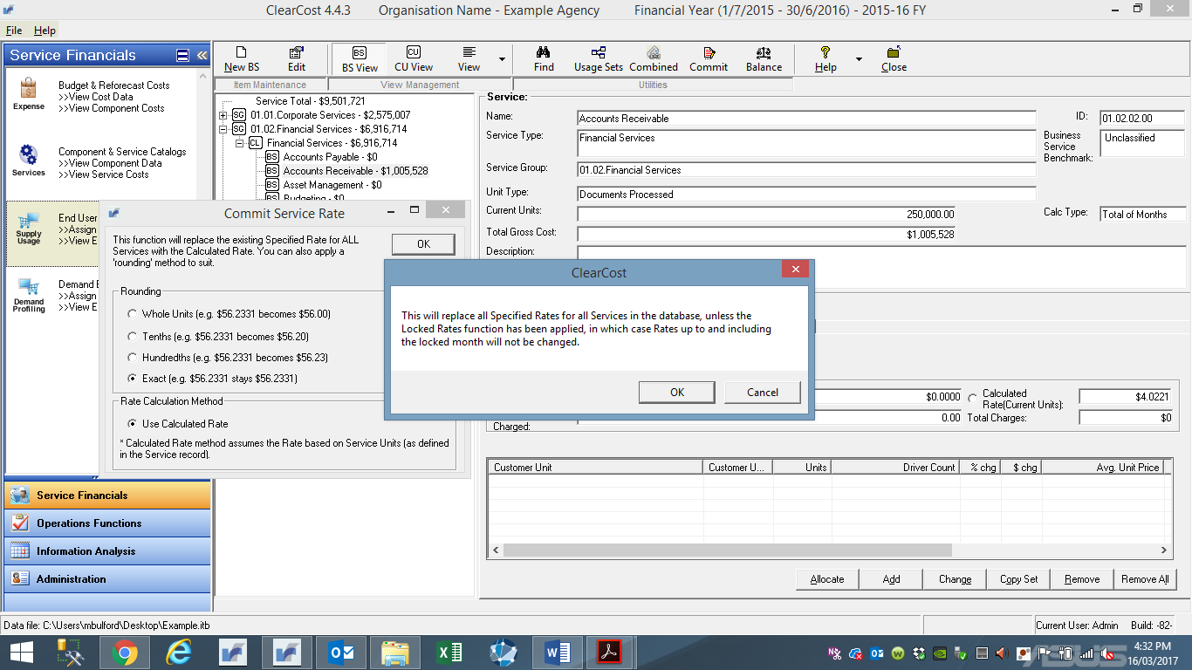

Click **OK** to commit the Rates. A **Rates Updated** message will display when the process is complete.

5. The Services window will redisplay with the updated information with the **Specified** **Rate** and **Calculated Rate** displaying the same rate.

# Basic Reporting

## Generating Reports

There are predefined reports within ClearCost. Use this procedure to preview and print these reports.

**Procedure**

1. On the Main Menu, click **Information Analysis** Category, then ensure **Report Menu** is selected.

The reports window will display.

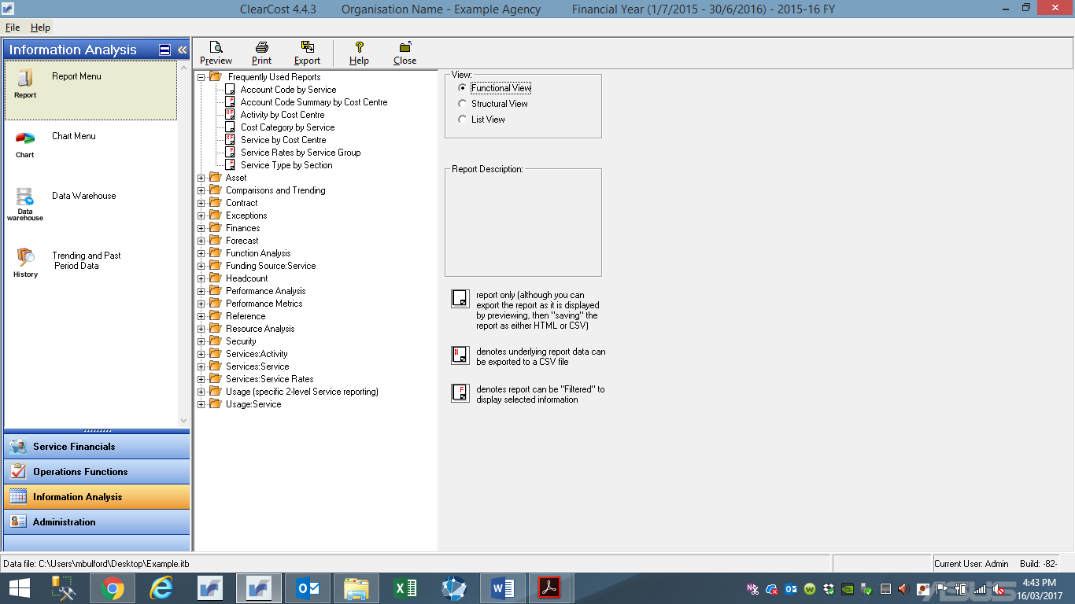

2. There are three displays of reports:

* **Functional** – groups reports by logical function (default view)
* **Structural** – groups reports by type of data reported (e.g. all financial, analytical and performance reports for Cost Centres appear under Cost Centre)
* **List** – a straight alphabetic list

Select the report you want to preview/print by clicking on its title.

3. To view the report, click **Preview**. From the preview window, you can print the report by clicking on the **Print** button or resize the on-screen view by selecting the percentage in the **Zoom** field.

4. To add the report to your **Frequently Used Reports** list, click on the report, right click to bring up the option **Add to Frequently Used Reports**, select that entry, and click on it.

5. You can export (in CSV format) the report or, in some cases, the underlying data that makes up the report.

* To export report
* Click **Preview**
* In the top left corner of the preview window, click the second button to export
* choose the file type (HTML for a look alike; Text for raw printed data)
* To export the underlying data (only some reports support this)
* Select the report in the menu
* Click the **Export** button on the Report Menu toolbar

NOTE – if the selected Report does not offer the underlying data as an Export option, you will receive a warning message “No export has been assigned to this report”.

* Nominate name and location.

## Generating Charts (Dashboards)

There are predefined charts within ClearCost, which are simple graphs of high level classifications and category information. All information in charts are also available in report format (Section 9.1). Use this procedure to preview and print these reports.

**Procedure**

1. On the Main Menu, click **Information Analysis** Category, then ensure **Chart Menu** is selected.

The charts window will display.

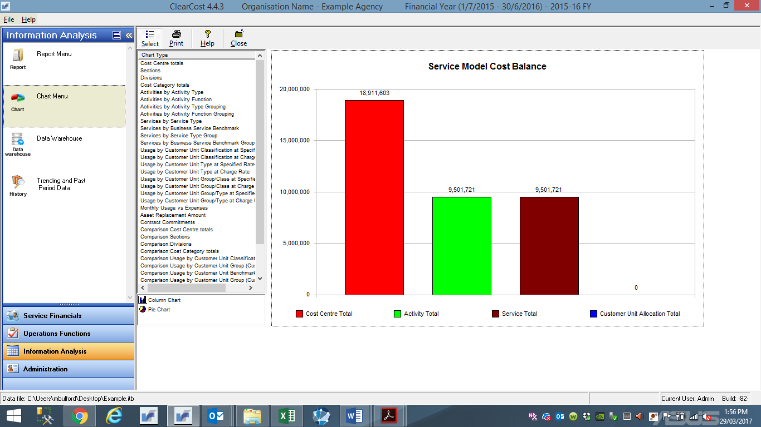

2. There are five chart types:

* **Cost Centre** – display total value of cost centre totals, sections, divisions, and cost categories.
* **Activities** – display activities by type, grouping, and function.
* **Services** – display total services by type, grouping, and function.
* **Usage** – display by customer total (**not applicable**)
* **Comparisons** – display comparisons for cost centre totals

Select the chart you want to preview/print by clicking on its title.

3. To view the chart, click the name. To vary the chart type from Column Chart to Pie Chart, click on the respective chart format. To hide/display the list click **Select** button.

4. Once you have selected the chart you can print, by simply clicking on **Print**.

**Please note**, the default chart (as displayed when first opening ClearCost – refer to Section 2.2) is **Service Model Cost Balance** chart (the last chart on the list). This chart is an important reference check as it provides the total for the cost-base, activities, and services. When all costs are allocated, each of these totals will equal.